924648807

<https://revistaseug.ugr.es/index.php/cpag/index>

Go to the website using based URL

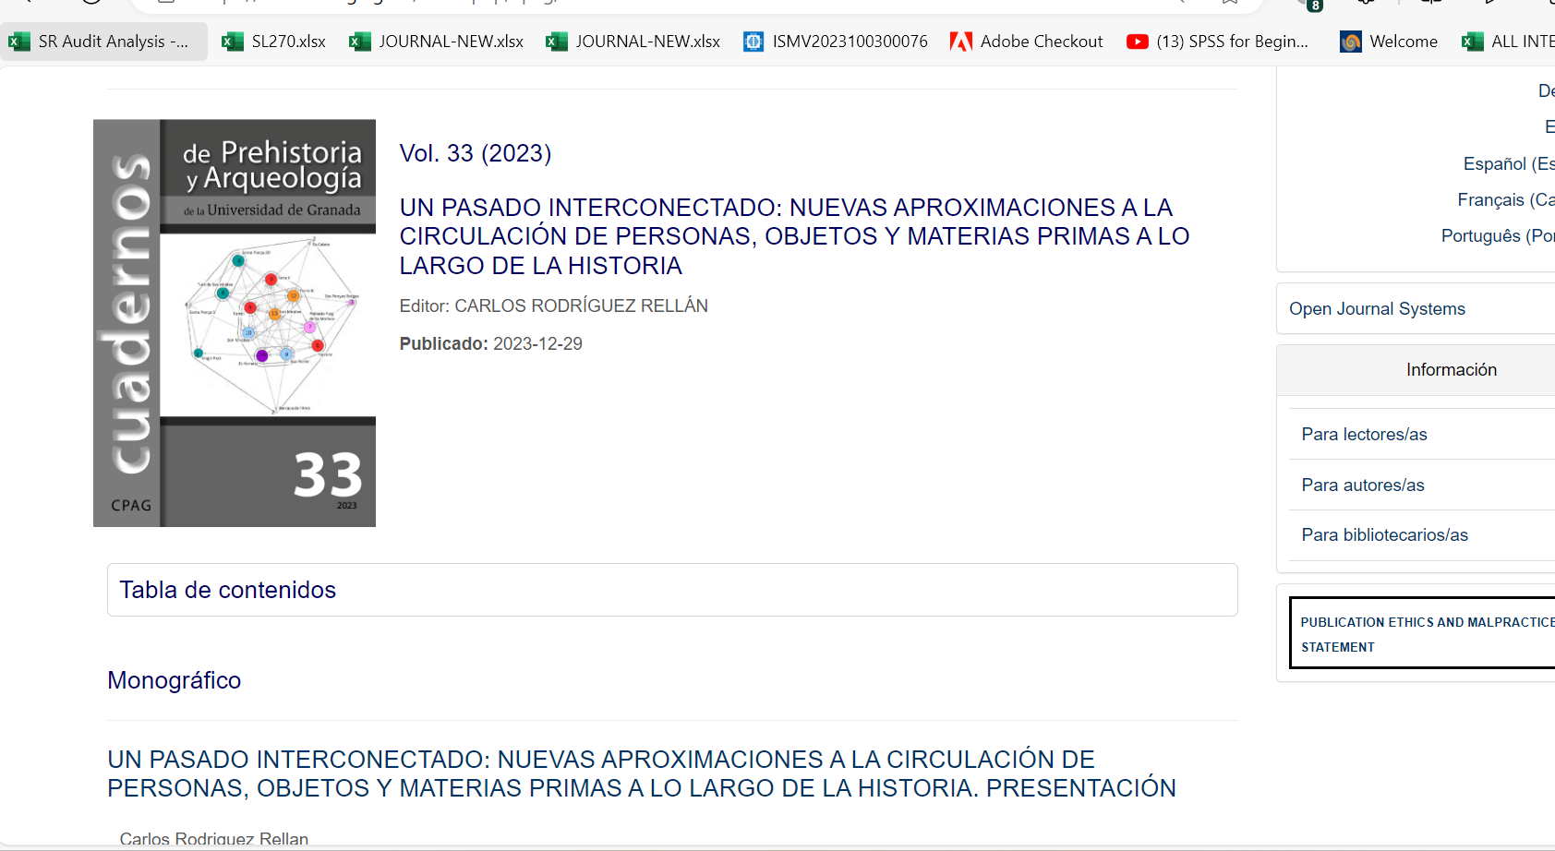

Click and Capture Article title

Capture volume

Capture year

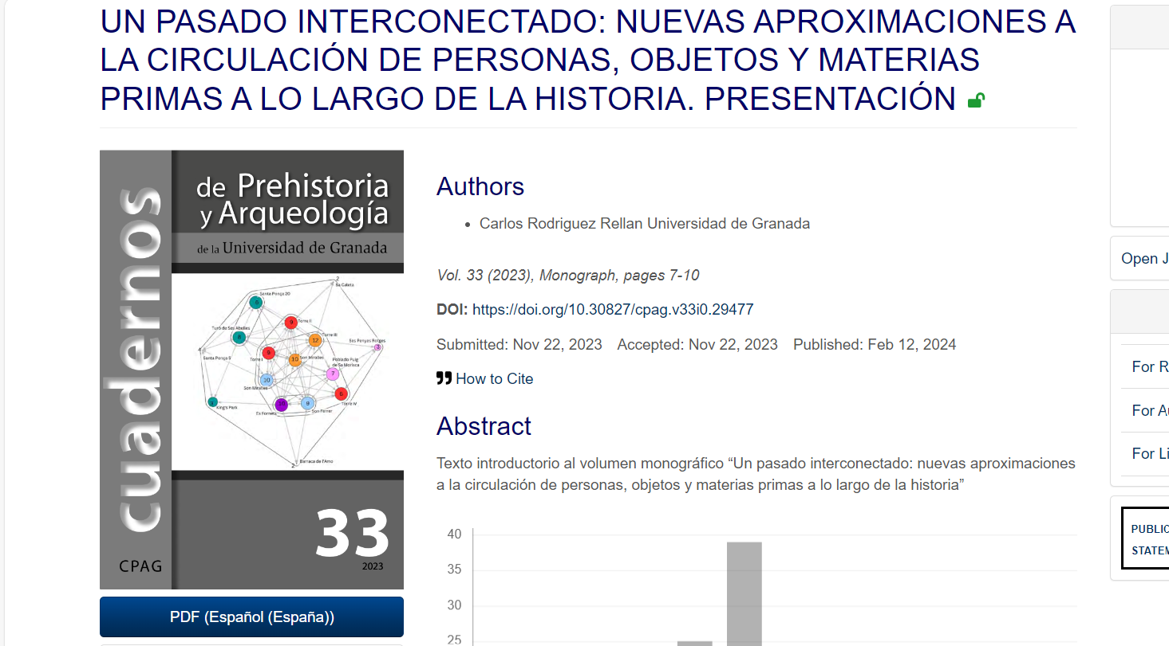

Click here to download pdf

Capture page range

Capture Doi