|  |  |
| --- | --- |
| 925212005 | https://scipost.org/SciPostPhys |
| 939594942 | https://scipost.org/SciPostPhysCore |

Above website have same structure.

Go to the website using based url you will get page like below.

Click here to get issue list

You will get issue list like below

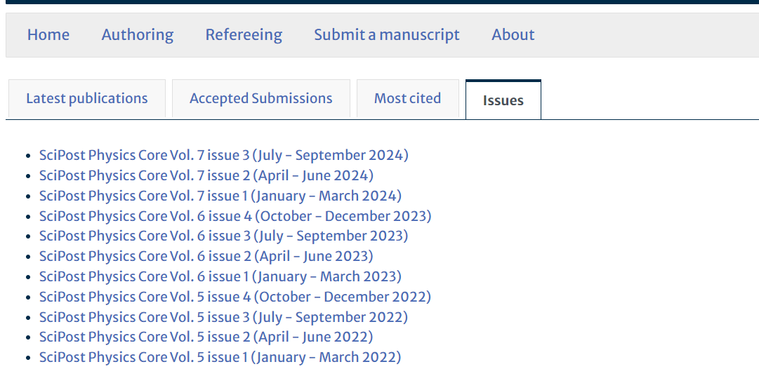

Finally click this to go to article list

Capture volume

Capture issue

Capture month

Capture year

Capture article title and click

You will get the article page like below.

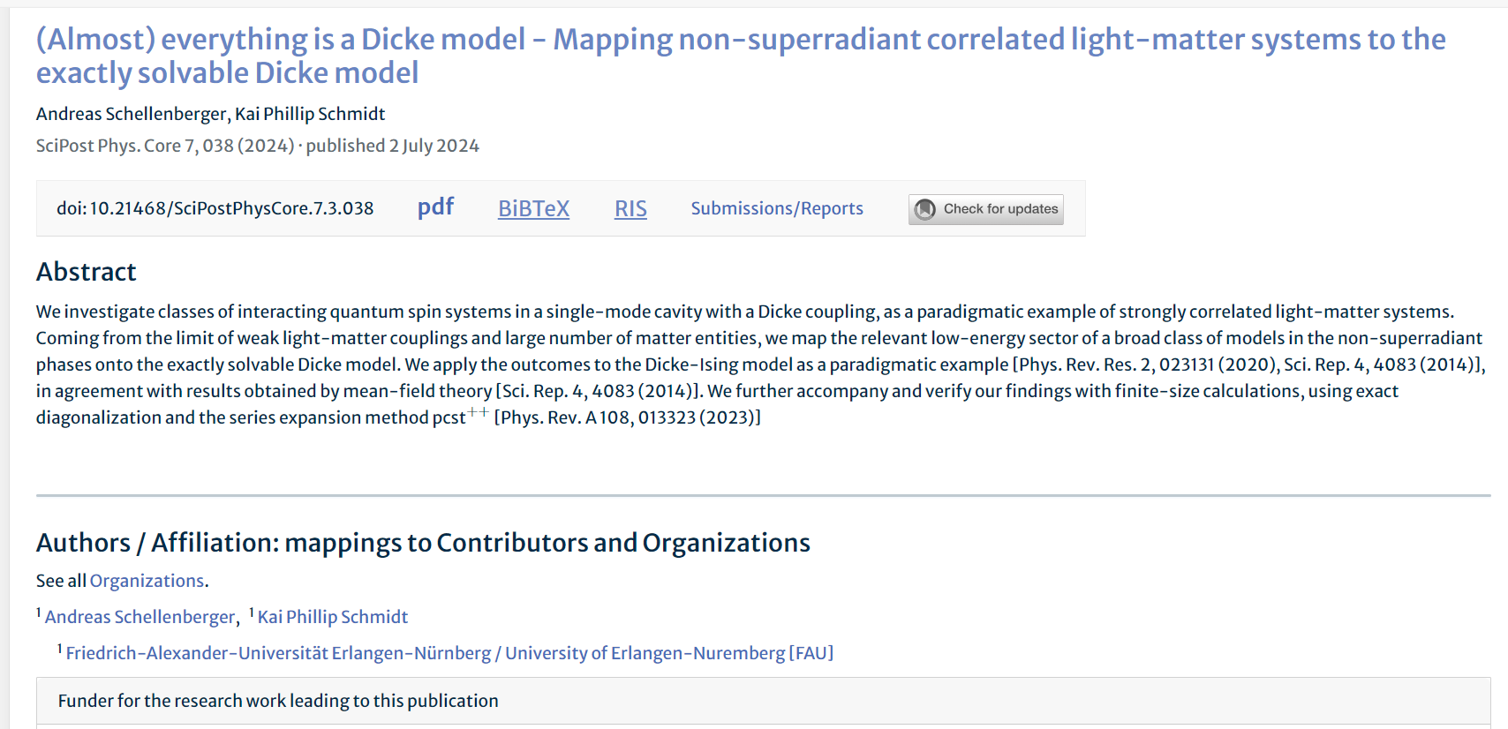

Click here to download pdf

Capture doi