**925313437**

Base URL:

Agreement URL: https://ijpds.org

* Use the Agreement URL as the main URL instead of using Source URL
* 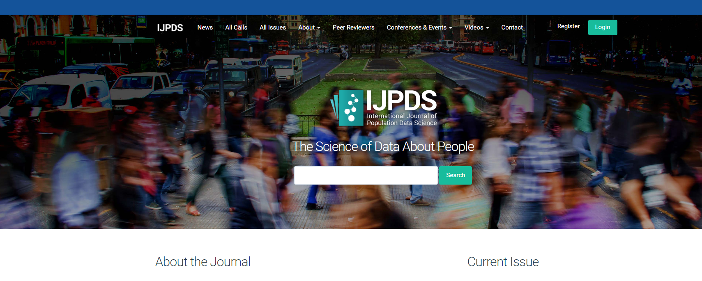Web page view as below
* Click all issues to access every volume and issue under that journal. As mention

Click here



* Every issue is separate in to different section. As below

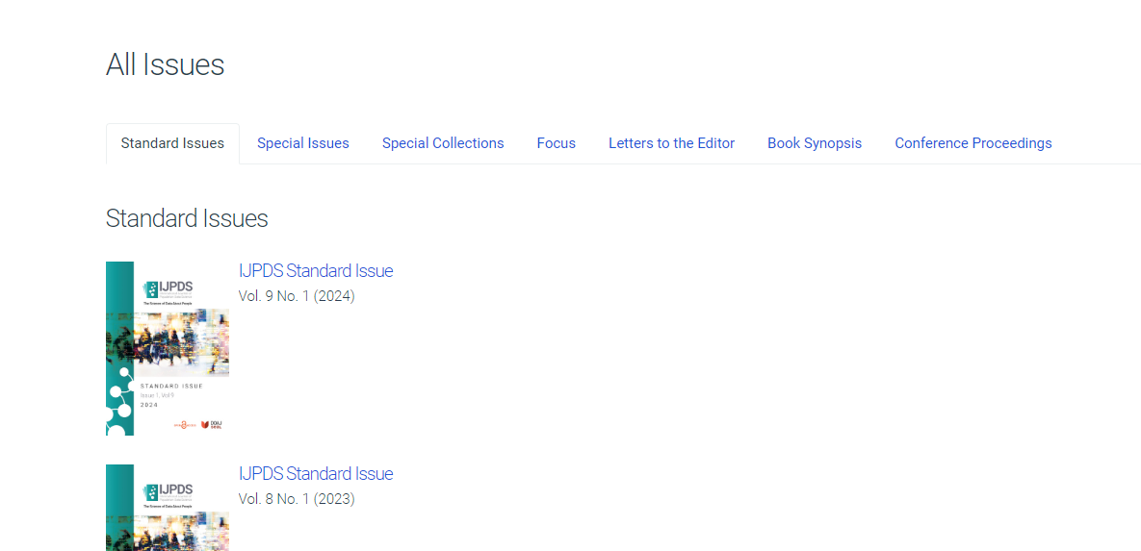

# Mate data can be capture as below

DOI and URL

Article Name

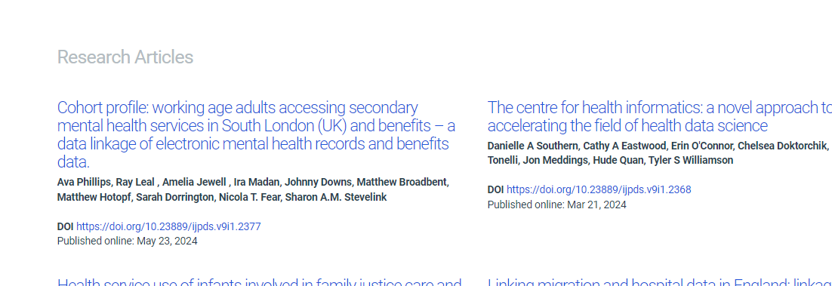

* Click article to download the PDF

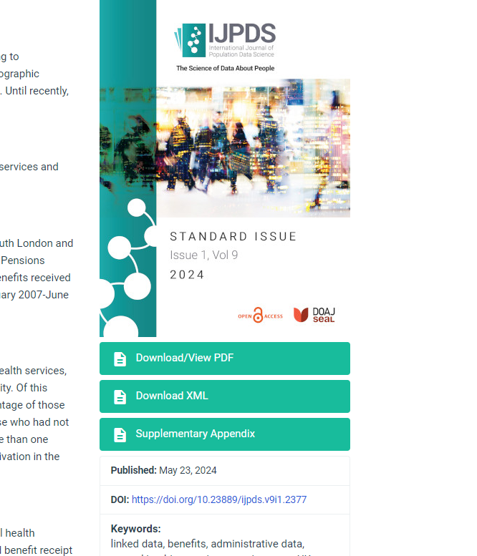

PDF