**295794299**

Base URL:

Agreement URL: http://ivyspring.com/

Go to the website by using the agreement URL and search the source title in the search bar or

Archive catalog display like this

Select the current issue

Select the previous issue

Volume and issue number & year

Title

Doi

Click on download to open the pdf

Click on the title and open the page to get the URL.

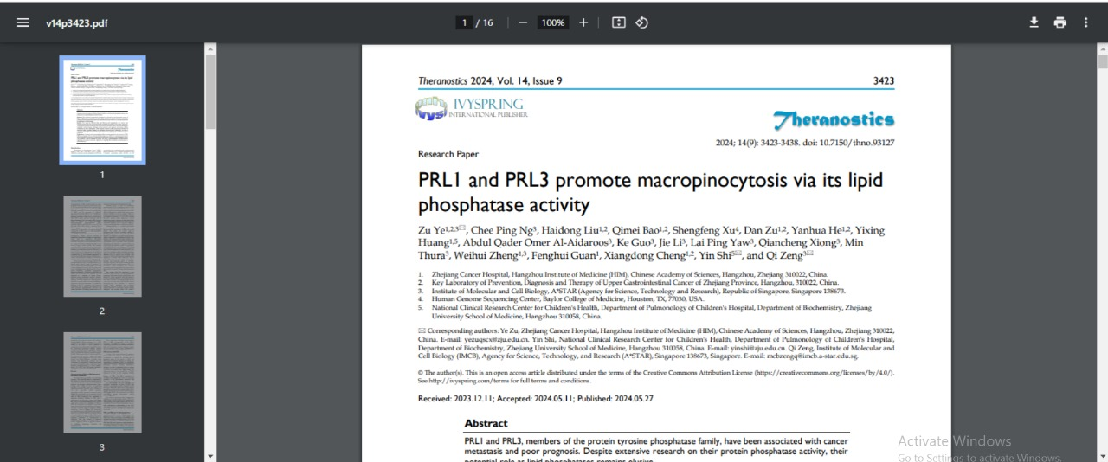

Download the pdf