657092713

<https://www.hxkqyxzz.net/EN/1000-1182/current.shtml>

Go to the website using the based url You will get current issue page.

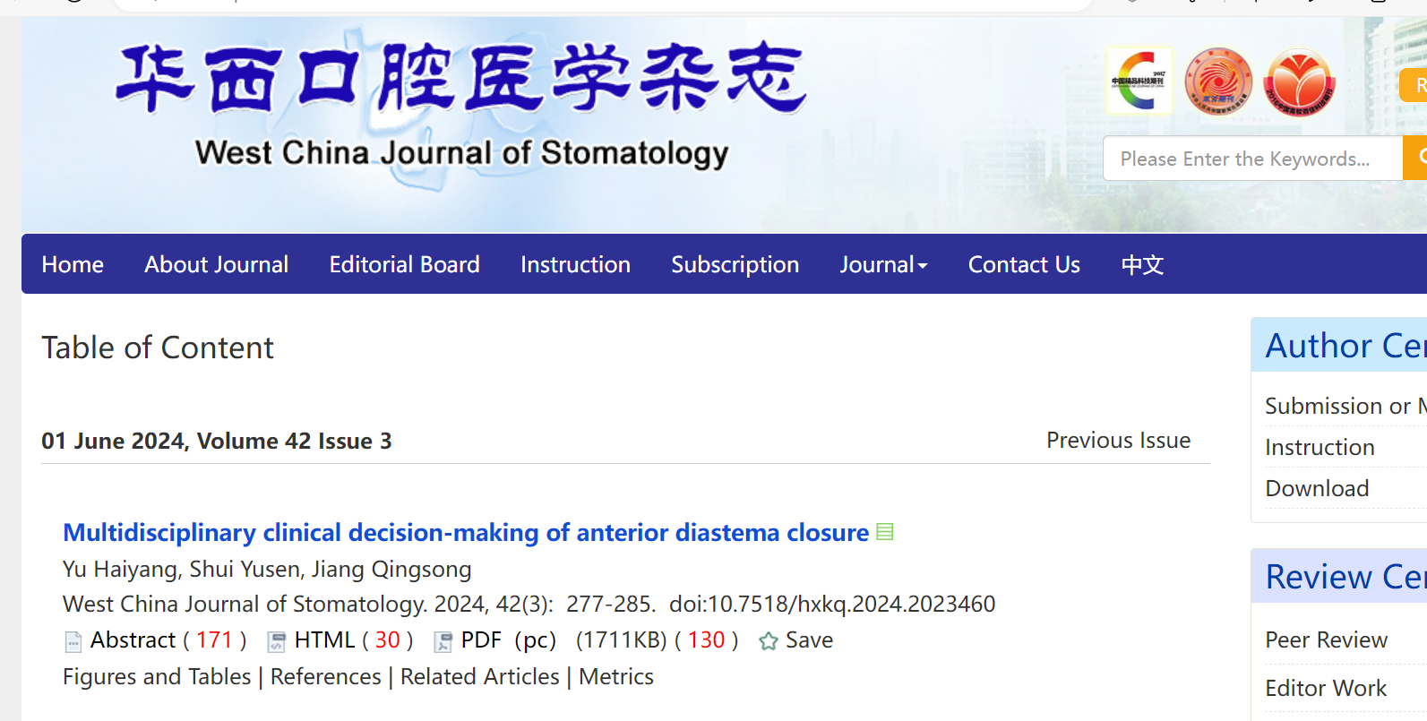

Capture Page range

Capture DOI

Click here to download

Capture Issue

Capture Volume

Capture Year

Capture Month

Capture date

* In here both English and Chinese toc needs to be captured so choose language option from website language conversion . then go to the Table of content page right click and save as pdf and merge in to one.