|  |  |
| --- | --- |
| 316510099 | https://ijpsr.com/articles/ |

Go to the website using based URL.You will get current issue page like below.

Capture year

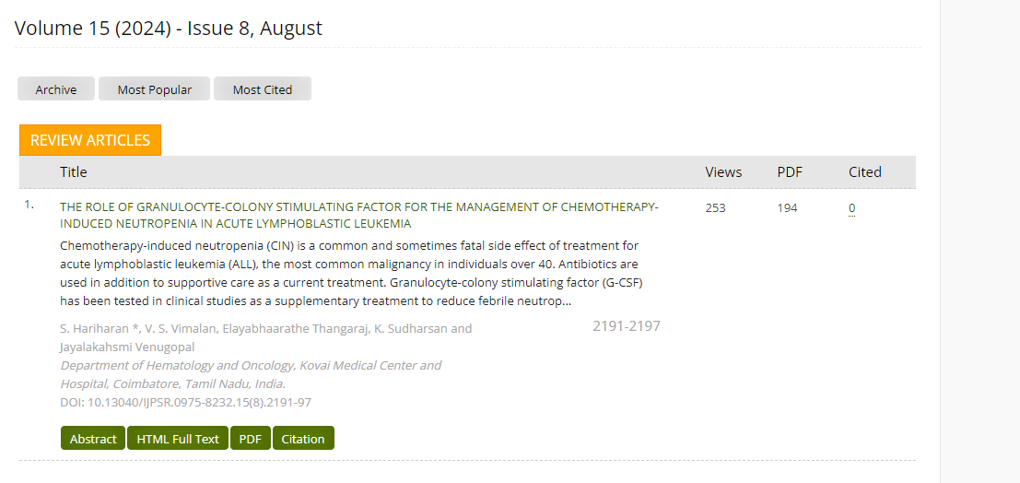

Capture title

Capture Date

Capture issue

Capture month

Capture page range

Capture DOI

Click here to download