Source ID – 911323683

Source Title - Enthymema

URL -https://riviste.unimi.it/index.php/enthymema

1. Go to the URL and capture the Metadata as shown below.

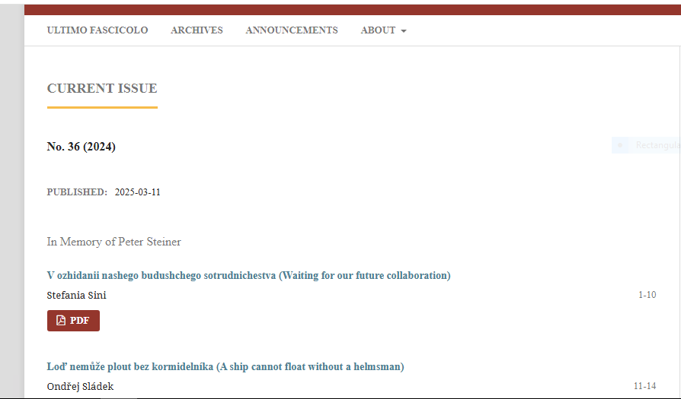

Article title

Page Range

Article title

Year

Issue

2. Clicking the PDF will direct you to the PDF viewer page

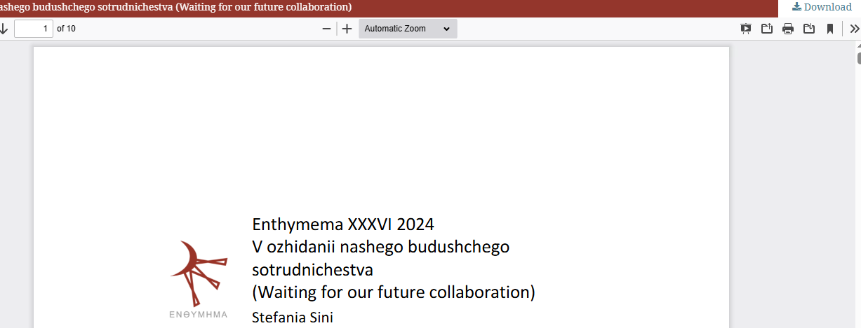

Click to the download PDF

3. DOI is available on the web site. Click the article title to capture to DOI.



Click the article title

4. After clicking article title will direct to the web page containing the DOI.

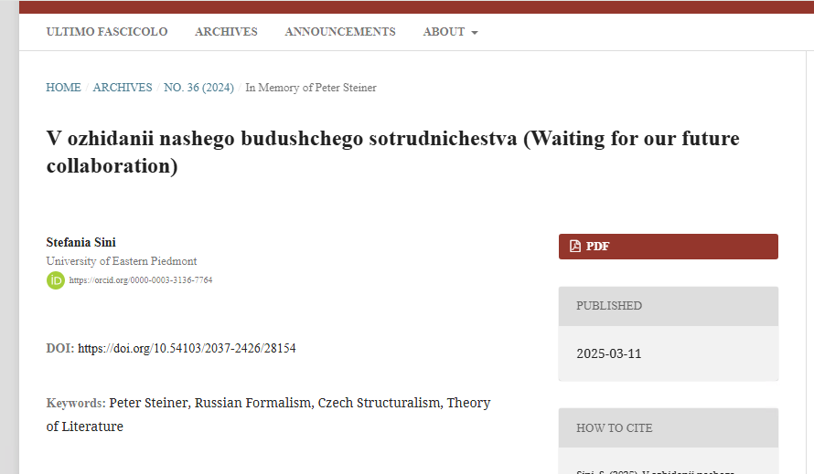

DOI