Source ID – 918729180

Source Title - Lebenswelt

URL -https://riviste.unimi.it/index.php/Lebenswelt

1. Go to the URL and capture the Meta data as shown below.

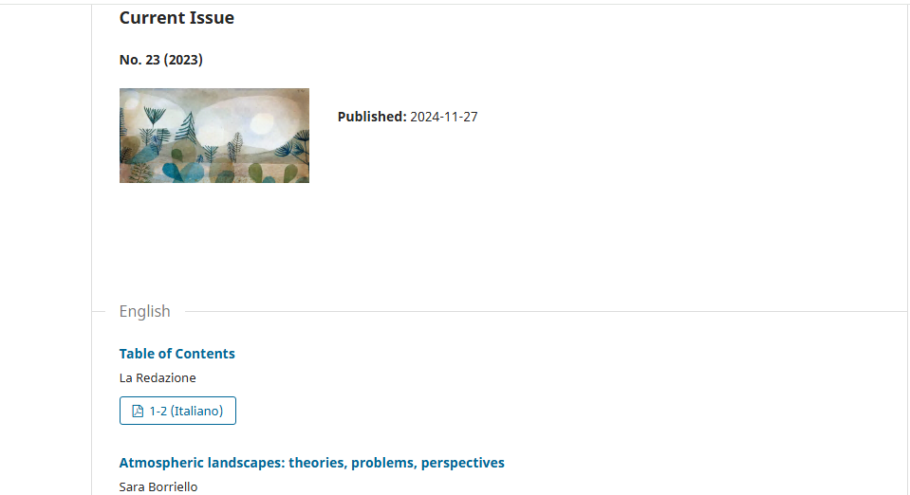

PDF

Article title

Year

Issue

2. Clicking the PDF will direct you to the PDF viewer page

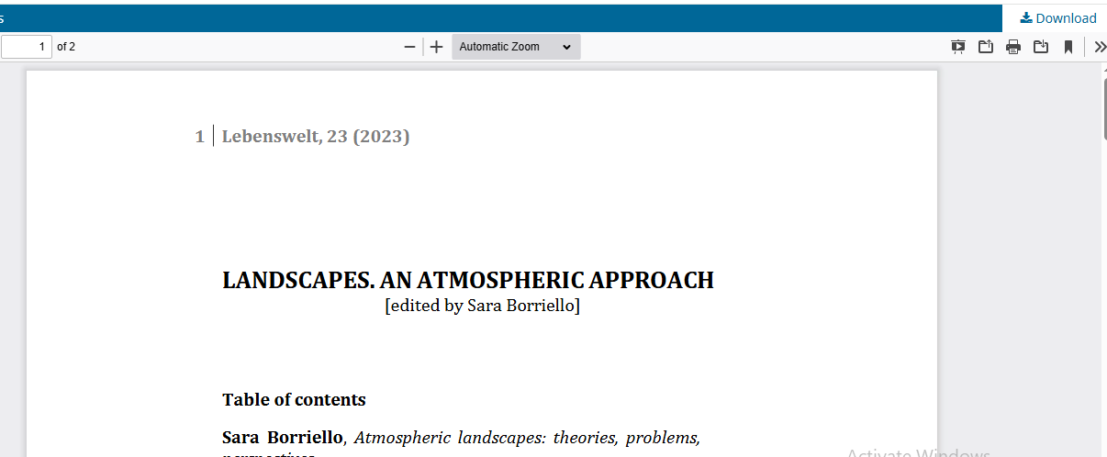

Click to the download PDF

Page Range

3. DOI is available on the web site. Click the article title to capture to DOI.



Click the article title

4. After clicking article title will direct to the web page containing the DOI.

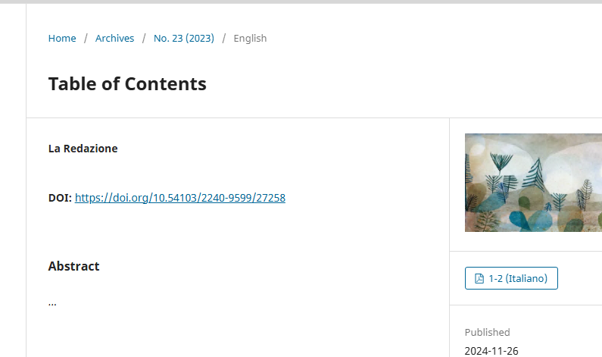

DOI