Source ID – 940176313

Source Title -Itinera

URL -https://riviste.unimi.it/index.php/itinera/issue/archive

1. Go to the URL and current issues in the website.

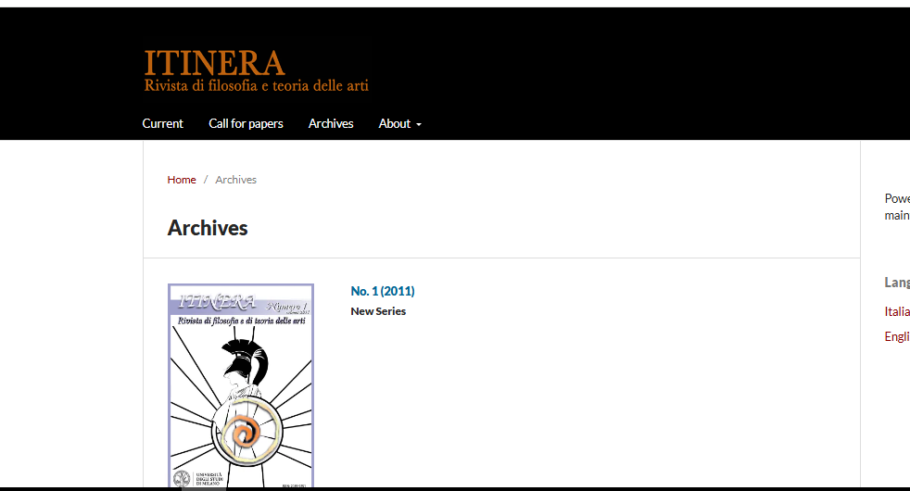

Select the current issue

2.Capture the meta data as shown below.

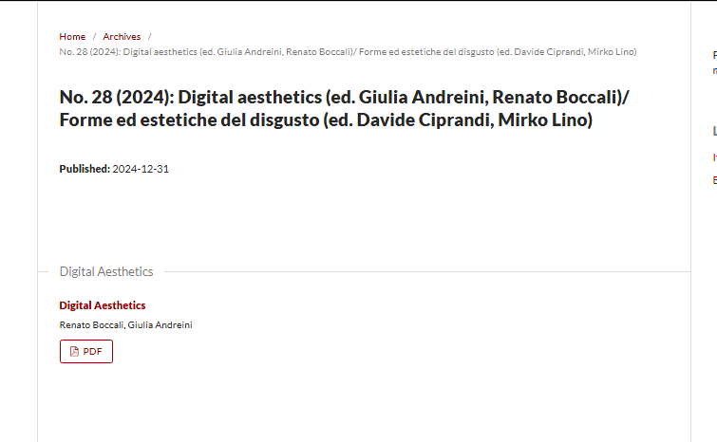

PDF

Article title

Year

Issue

3. Click the article title to capture to DOI.

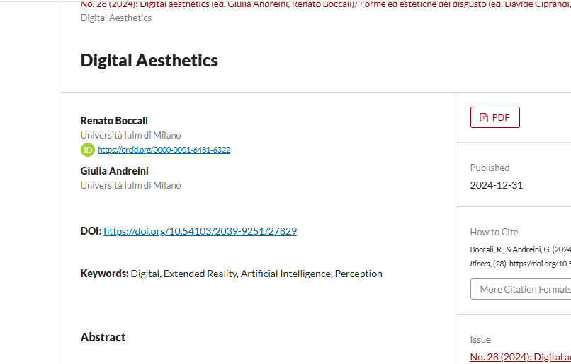

DOI

4. Clicking the PDF will direct you to the PDF viewer page.

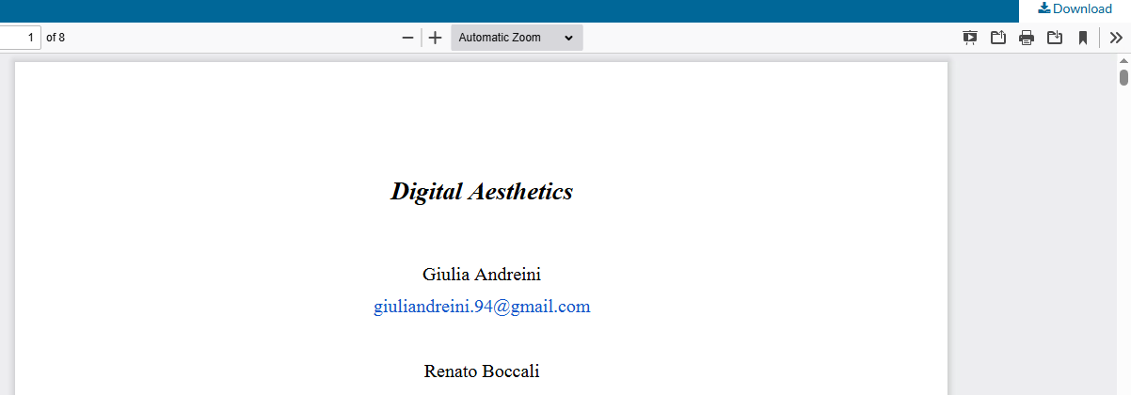

Click to the download PDF