Please note following source websites have the same structure.

|  |  |  |
| --- | --- | --- |
| **Source ID** | **Source Title** | **URL** |
| 923141276 | Studia Theodisca | https://riviste.unimi.it/index.php/StudiaTheodisca/index |
| 701280756 | Studia Austriaca | https://riviste.unimi.it/index.php/StudiaAustriaca |

1. Go to the URL and select the current issue.



Current issue

2. Capture the metadata as shown below.

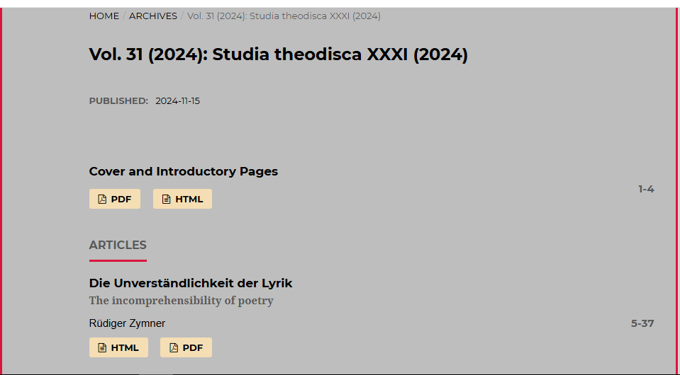

PDF

Page range

Article title

Year

Volume

**Note: In these journals of this Ref the first article is cover page. DOI is available second article onwards.** **So Second article used to example to capture the DOI.**

3. DOI is available on the web site. Click the article title to capture to DOI.



Click the article title to capture DOI

4. After clicking article title will direct to the web page containing the DOI. It should be captured.

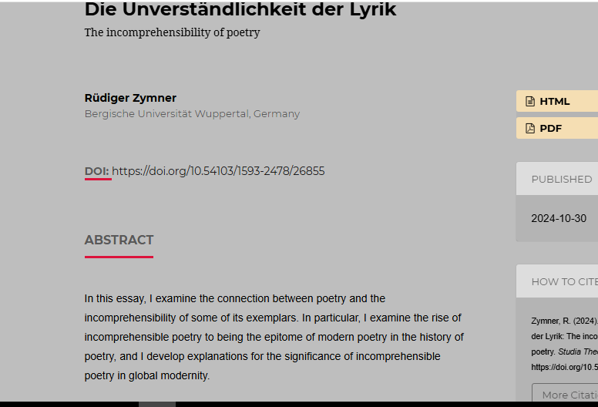

DOI