|  |  |
| --- | --- |
| 942655741 | https://agrolifejournal.usamv.ro/index.php/agrolife |

Go to the website using the based url. You will get current issue like below,

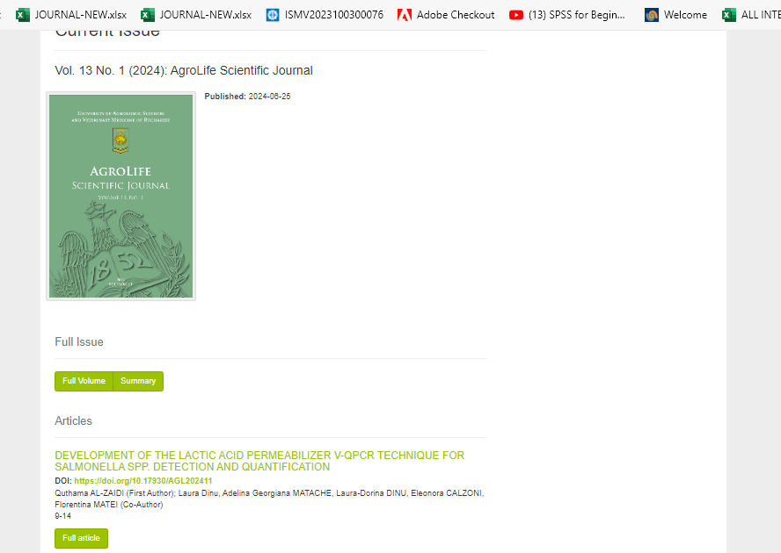

DOI

Page range

Article title

Volume

Year

Issue

Click here to download