|  |  |
| --- | --- |
| 951527251 | https://www.zgdzzhyfzxb.com/en/article/current |

Go to the website using the based url. You will get webpage like below.Change the language in to English by using website language converter.

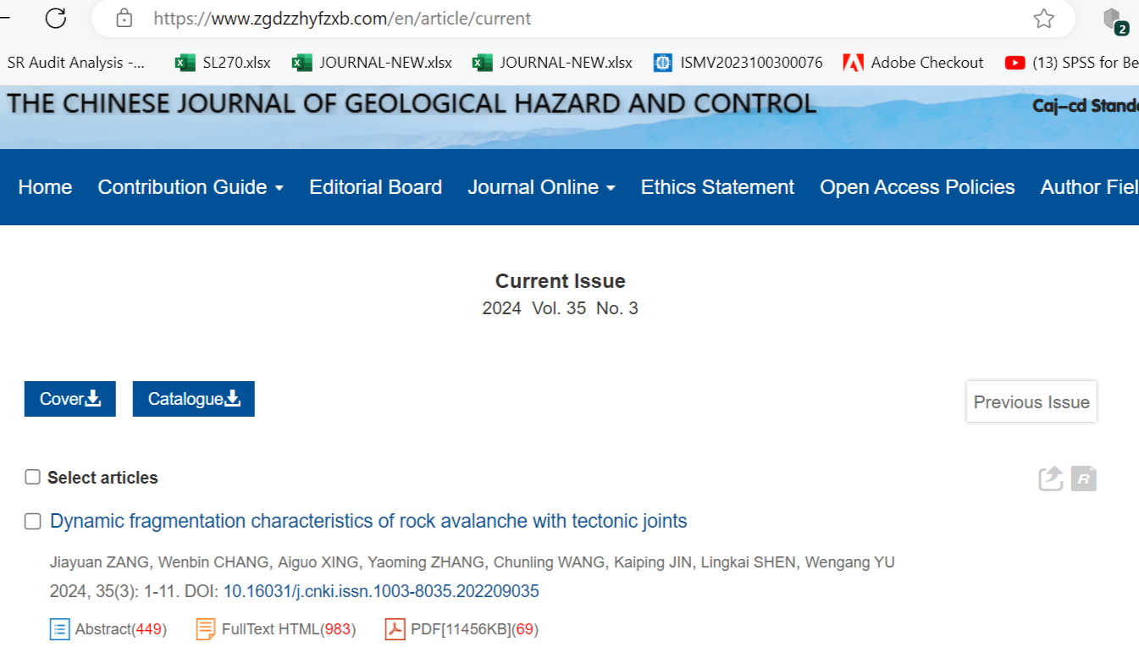

Click here to download

Doi number

Page range

Volume

Issue

Year

Need both English and non roman tocs