Source ID: 943988000

Source Title: Journal of Graphics

Agreement URL: <http://www.txxb.com.cn/CN/2095-302X/home.shtml>

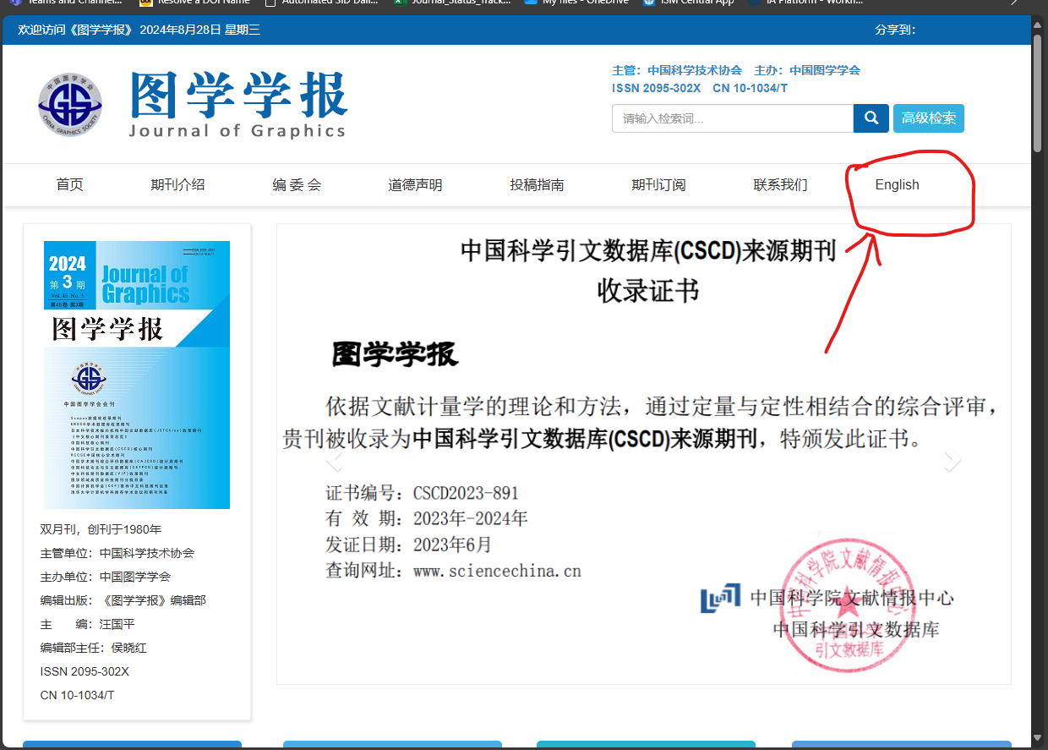

**Click here to switch language**

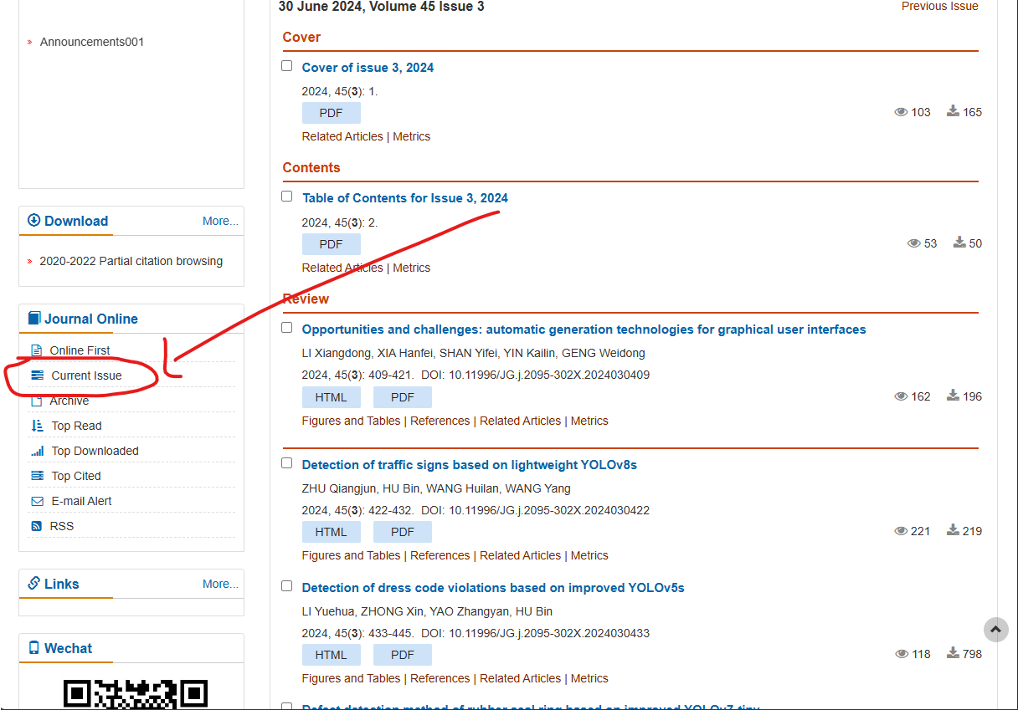

**Current issue**

**Issue**

**volume**

**Date**

**Month**

**Year**

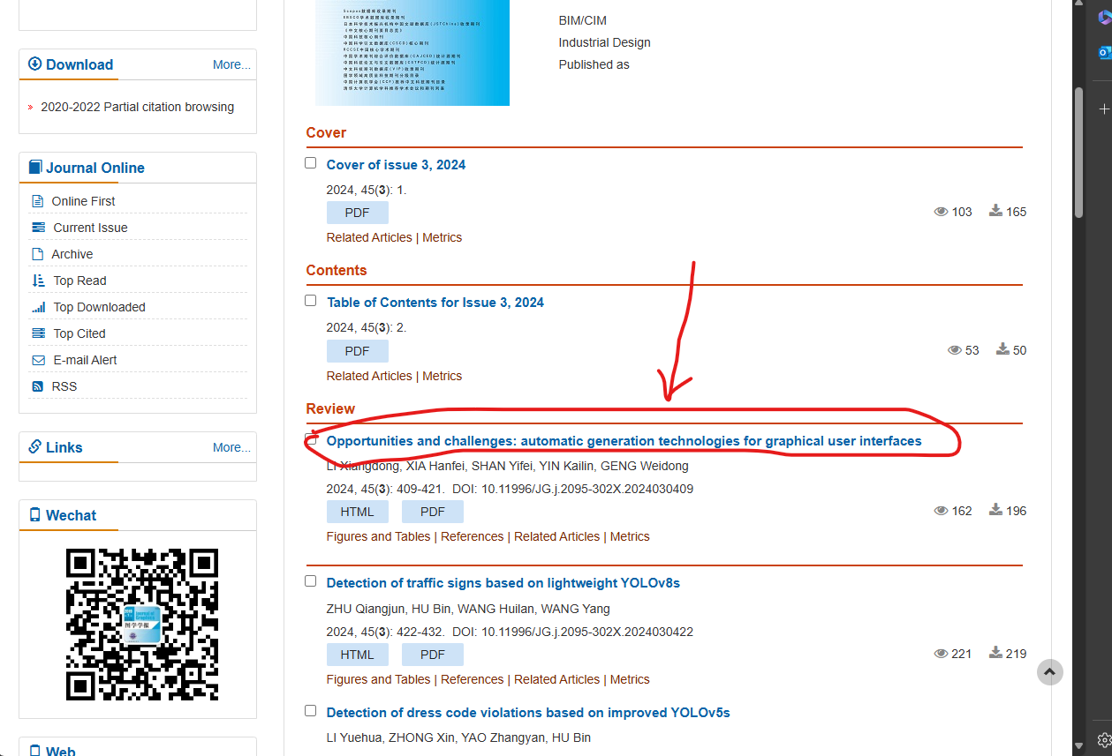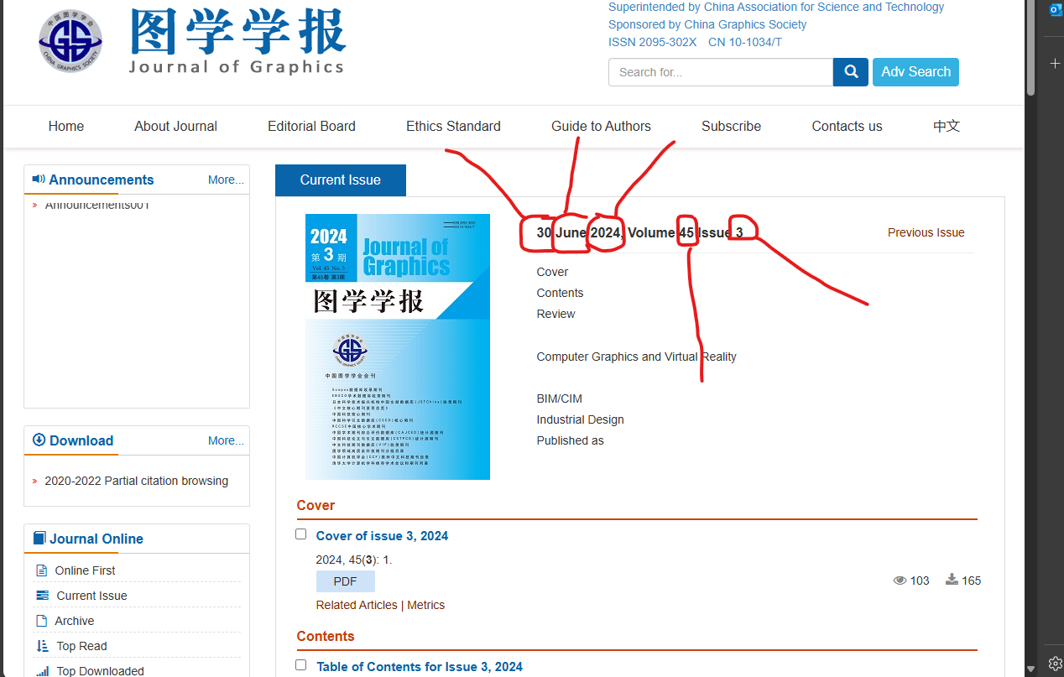

**Click on article title**

**Click here to download PDF**

**Page Range**

**DOI**

**Title**

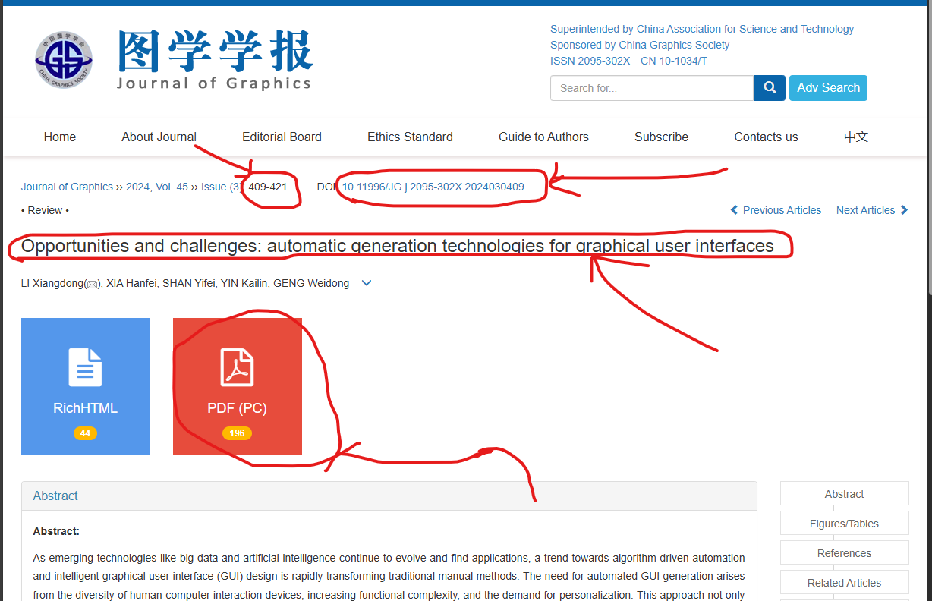

**\*both English & Chinese TOC need to attached with template in PDF formate**