Source ID – 935035161

Source Title - Biophysics Reports

Current Issue URL - <http://www.biophysics-reports.org/article/current>

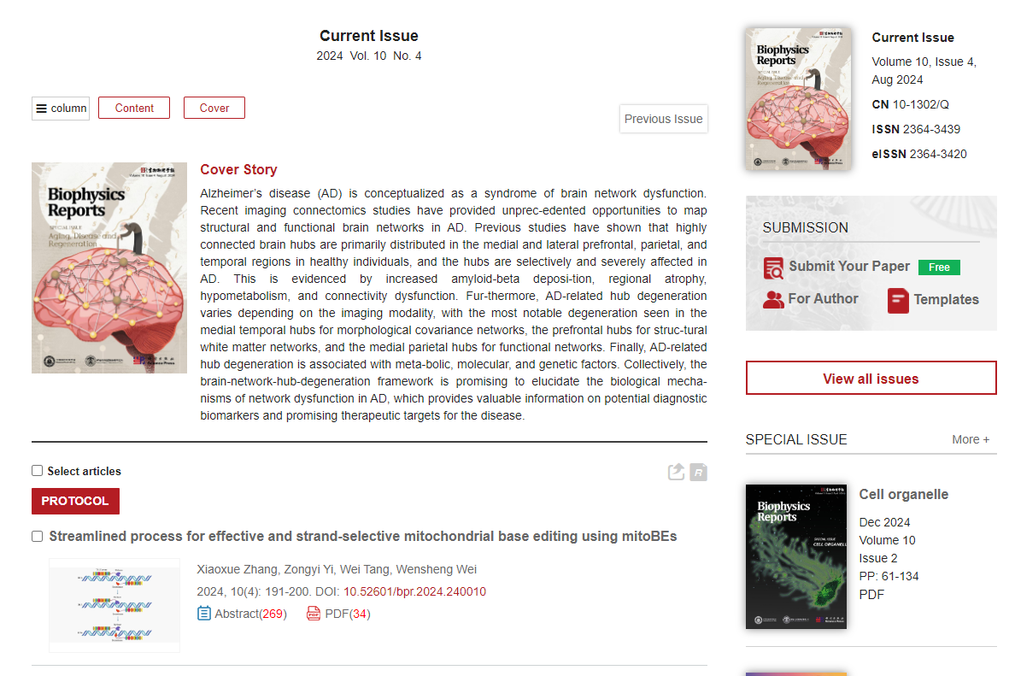

Year

Volume

Issue

Month

Article title

DOI

Pages

PDF