Source ID - 943736823

Source Title - SSRG International Journal of Electrical and Electronics Engineering

Current Issue URL - <https://www.internationaljournalssrg.org/IJEEE/current-issue.html>

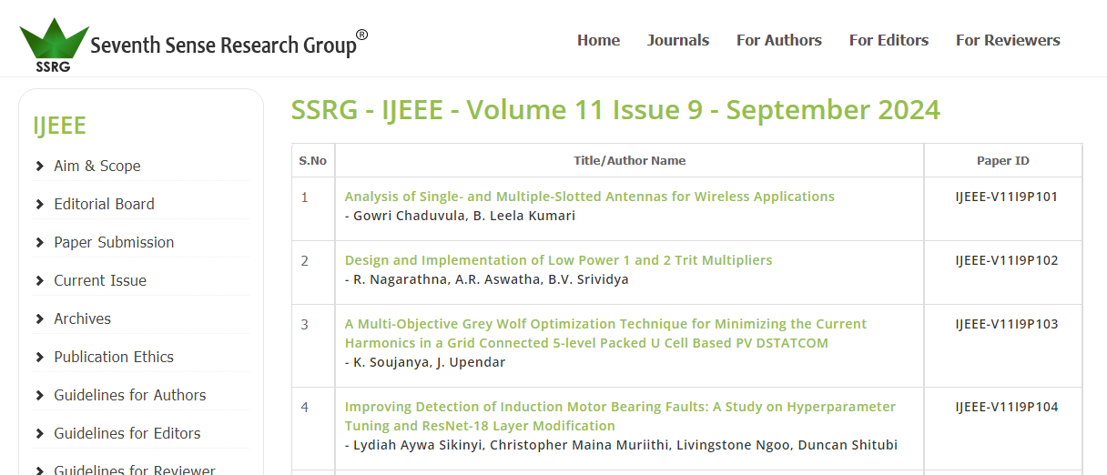

Click to capture meta data

Year

Month

Issue

Volume

Page range

PDF

DOI number

Article title