948141015

Agreement url:   
  
  
ejvs.journals.ekb.eg

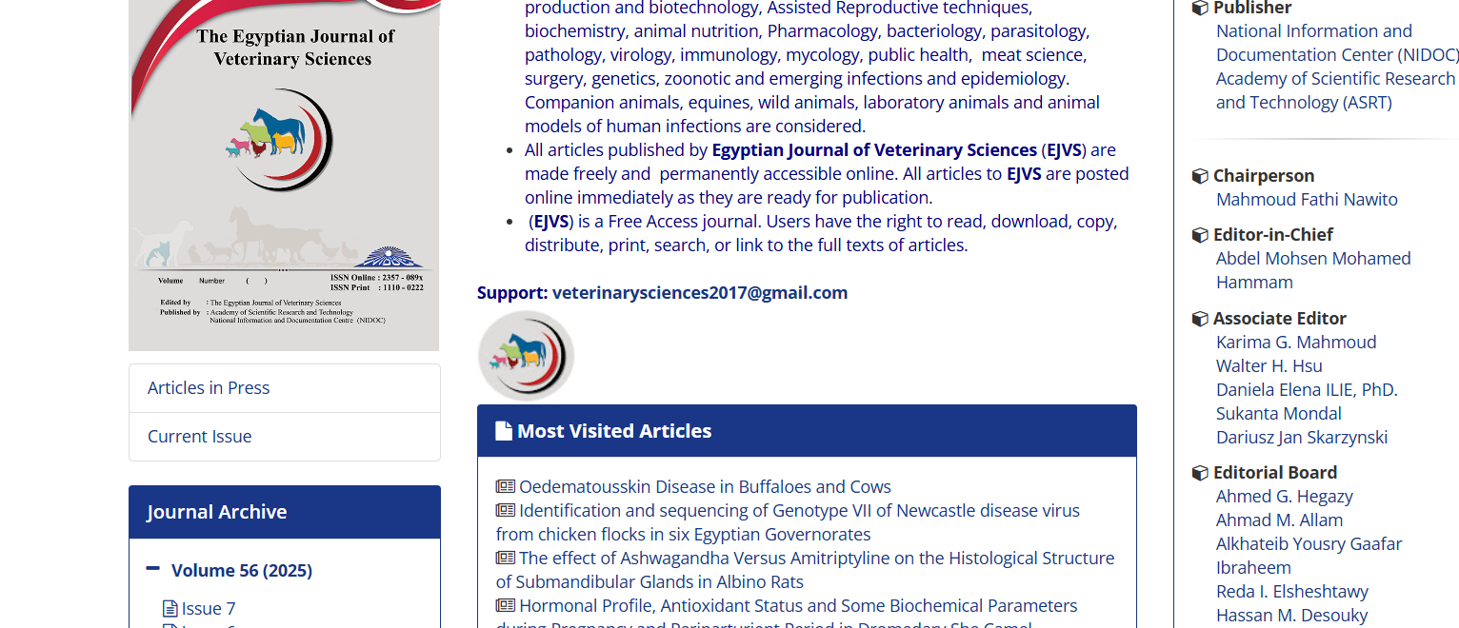

Current Issue

Publication year, Month, volume, issue

Page Range

DOI

English title

Download the pdf