Source ID - 938417519

Source title - Bulletin of Botanical Research

Agreement URL – bbr.nefu.edu.cn/EN/1673-5102/home.shtml

NOTE – English and Chinese TOC should be captured.

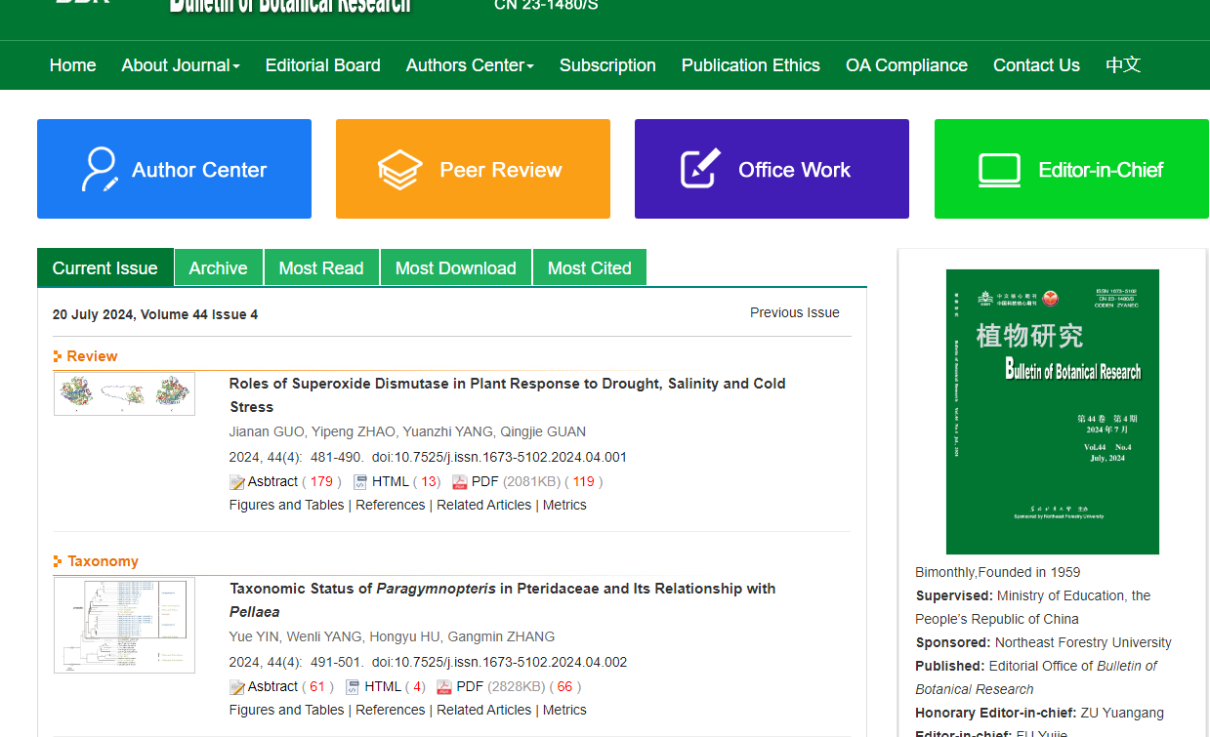

Volume

Issue

Month

Year

Date

Click article title to capture meta data

Page range

Click here to download PDF

DOI number

Article title