**78084099**

Base URL:

**http://www.pibb.ac.cn/pibben/ch/reader/issue_list.aspx?year_id=2015&quarter_id=8**

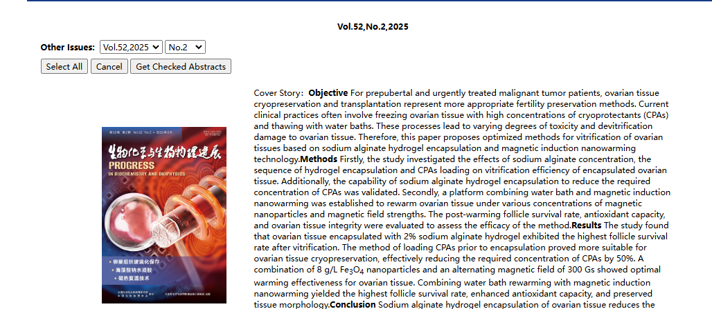

**Select the current issue from here**

* Meta data can be captured as below.

**Volume, Issue and Year**



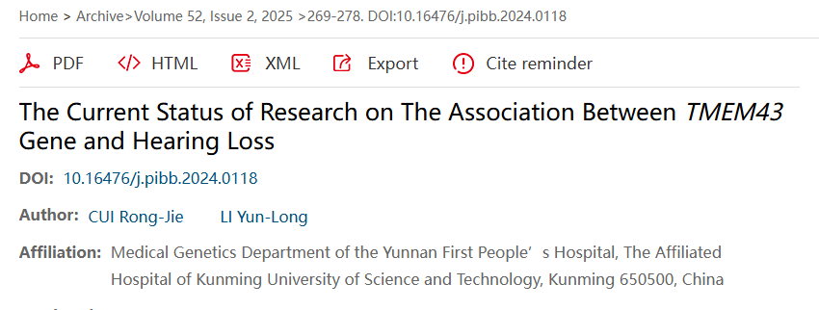

**Click here to download the pdf**

**Page range**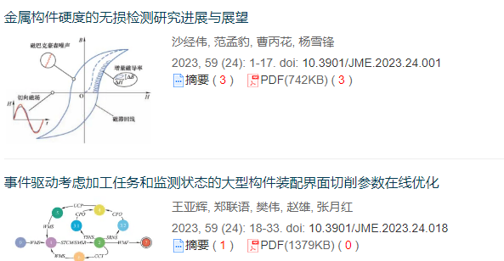

**DOI**

**Article Name**

* In here Chinese toc needs to be captured so choose language option from website language conversion . Then go to the Table of content page right click and save as pdf.