|  |  |
| --- | --- |
| 78622499 | https://www.epae.cn/dlzdhsb/ch/index.aspx |

Need non roman toc for this

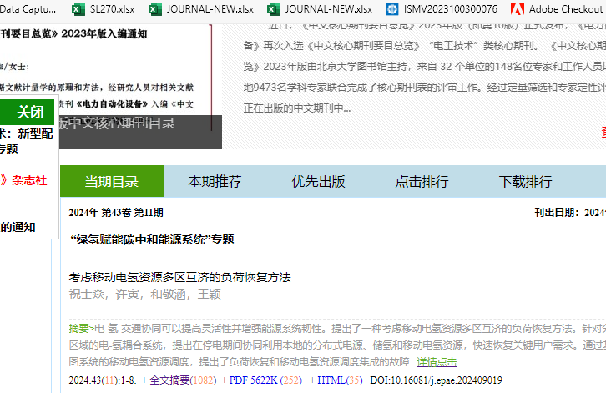

Click here

Year

Volume

Issue

Pdf download

Doi

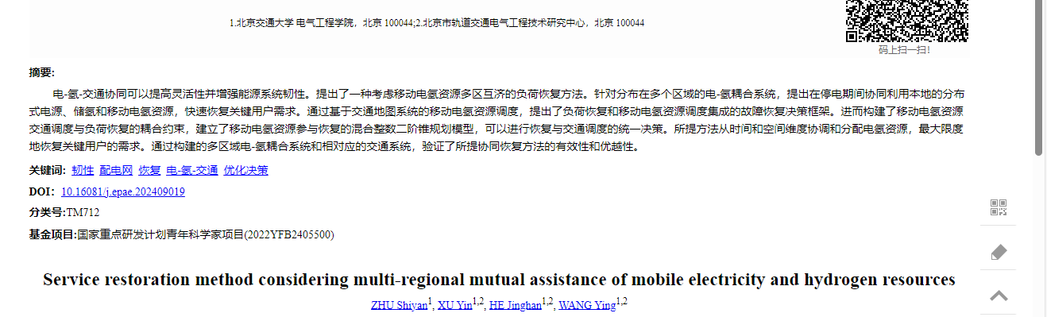

Capture article title