**946143417**

Base URL:

**http://jhydz.com.cn/indexen.htm**



**Select the Current issue from here.**

* Meta data can be captured as below.

**Volume, issue and Year**



**Page Range**

**Page range**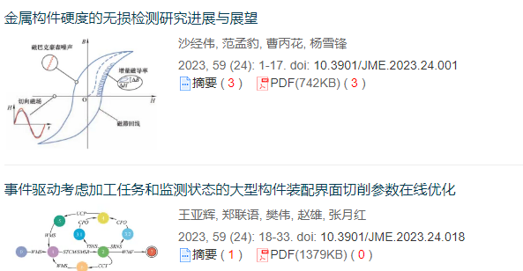

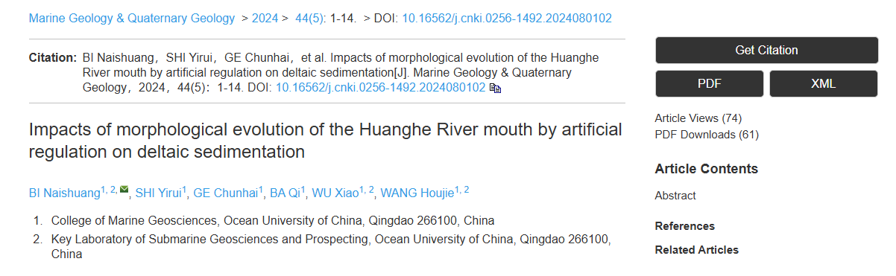

**DOI**

**Article Name**

**Click here to download the pdf and XML**

* In here Chinese toc needs to be captured so choose language option from website language conversion . then go to the Table of content page right click and save as pdf.