Source ID – 295794999

Source Title - Infection and Chemotherapy

URL - <https://www.icjournal.org/index.php?body=current>

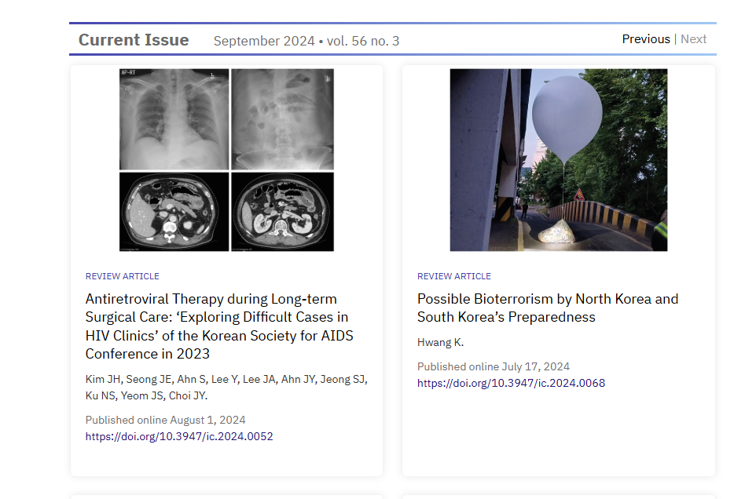

DOI

Article title

Issue

Month

Year

Volume

After extracting the metadata click the article title.

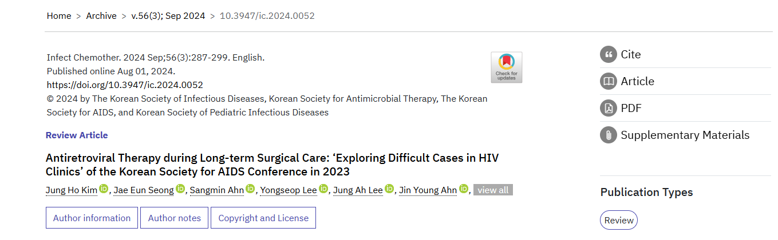

Pages

PDF