**77883799**

Base URL:

**http://www.aas.net.cn/CN/volumn/current.shtml**

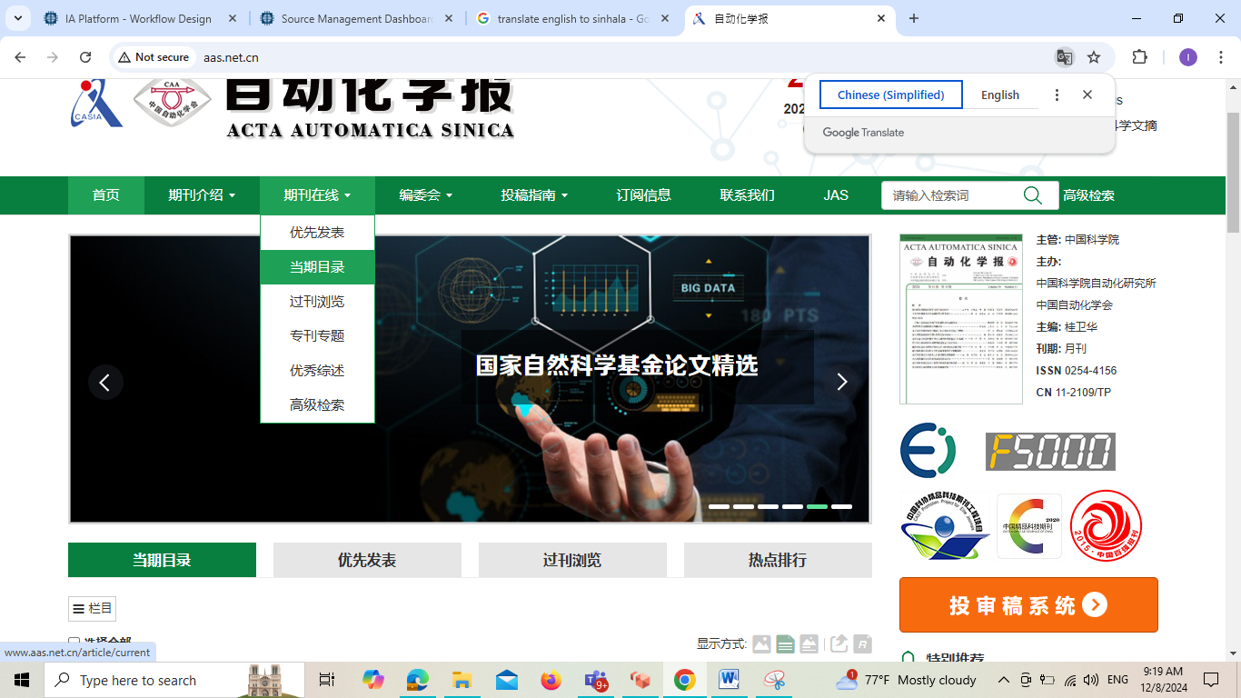

**Select the Current issue from here.**

* Meta data can be captured as below.

**Volume, Issue and Year**



**Page Range**

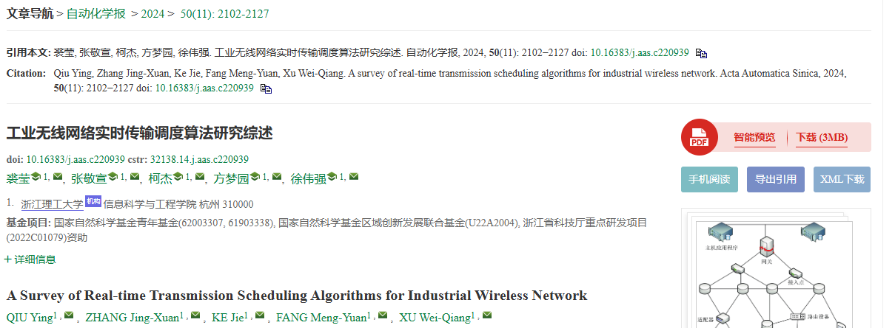

**Page range**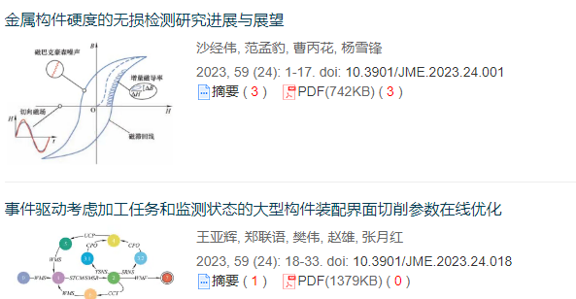

**DOI**

**Click here to download the pdf**

**Article Name**

* In here Chinese toc needs to be captured so choose language option from website language conversion . then go to the Table of content page right click and save as pdf.