**944970221**

Base URL:

**https://medtech.mphu.edu.ua/issue/archive**

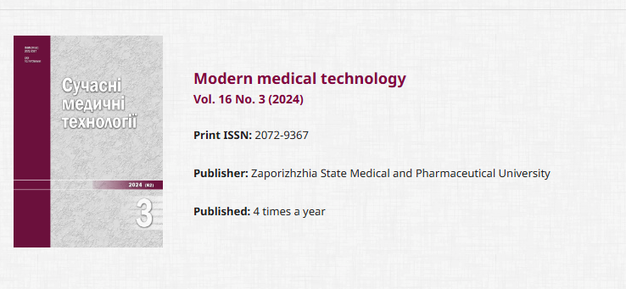

**Select the Current issue from here.**

* Meta data can be captured as below.

**Volume, Issue and Year**



**Page Range**

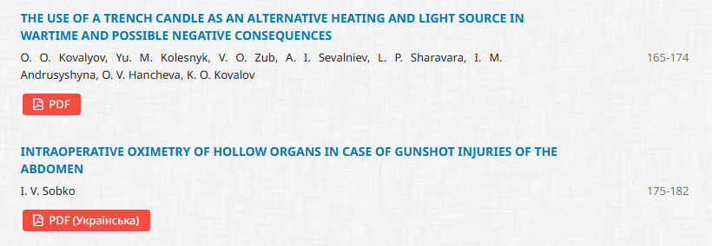

**Page range**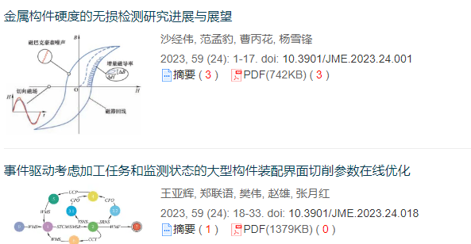

**Article Name**

**Click here to download the pdf**

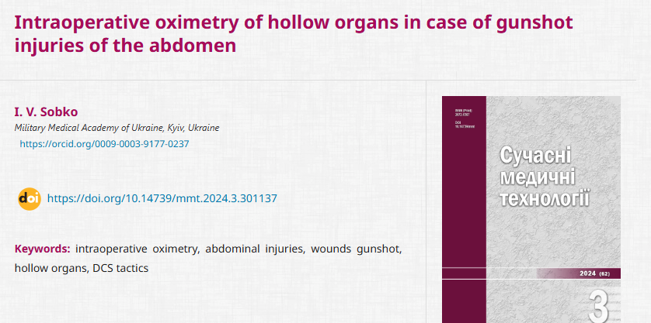

**DOI**

* In here Ukrainian toc needs to be captured so choose language option from website language conversion . then go to the Table of content page right click and save as pdf.