**935529050**

Base URL:

**nytsqb.aiijournal.com/EN/1002-1248/home.shtml**

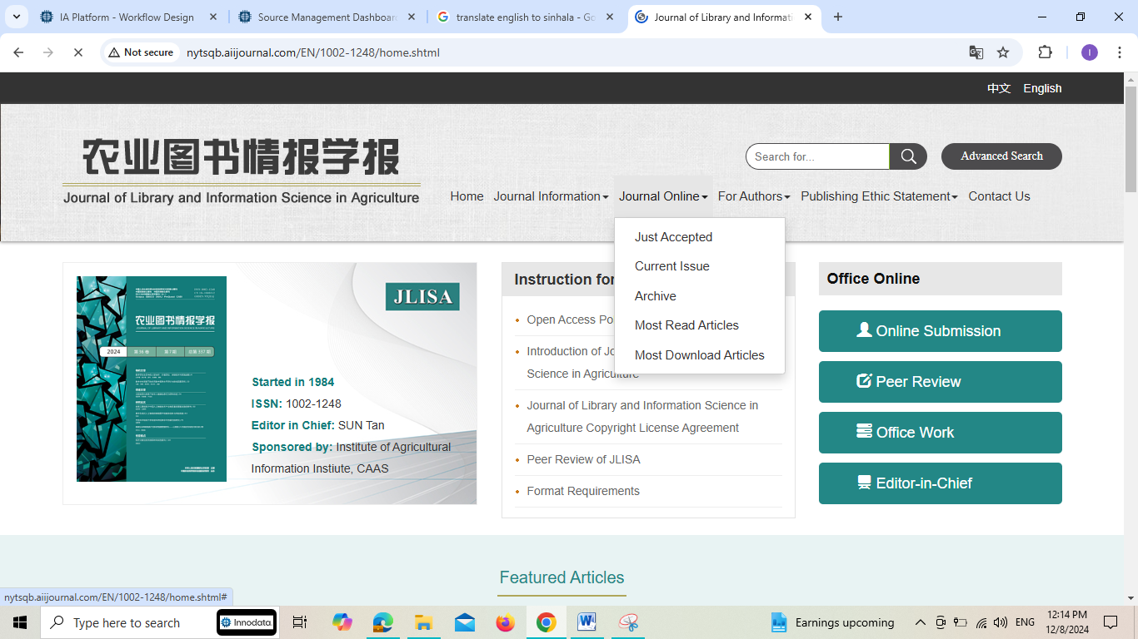

**Select the Current issue from here.**

* Meta data can be captured as below.

**Volume, Issue, Month , Date and Year**



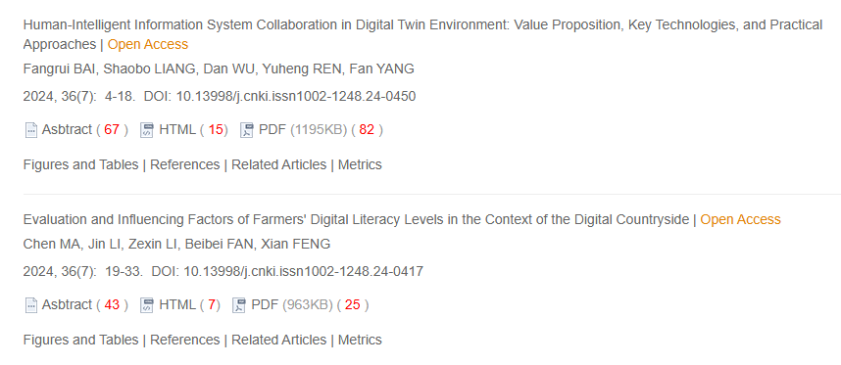

**Page range**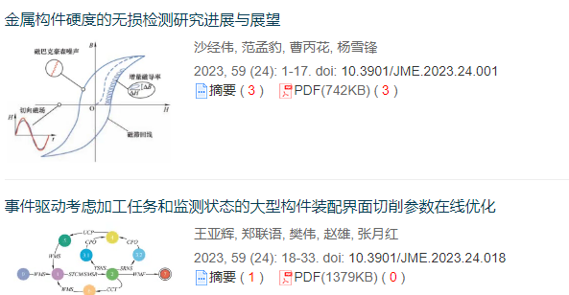

**DOI**

**Article Name**

**Click here to download the pdf**

* In here Chinese toc needs to be captured so choose language option from website language conversion . then go to the Table of content page right click and save as pdf.