Source ID - 77883199

Source title - Zhongguo Gonglu Xuebao/China Journal of Highway and Transport

Agreement URL - http://zgglxb.chd.edu.cn

NOTE – English and Chinese TOC should be captured.

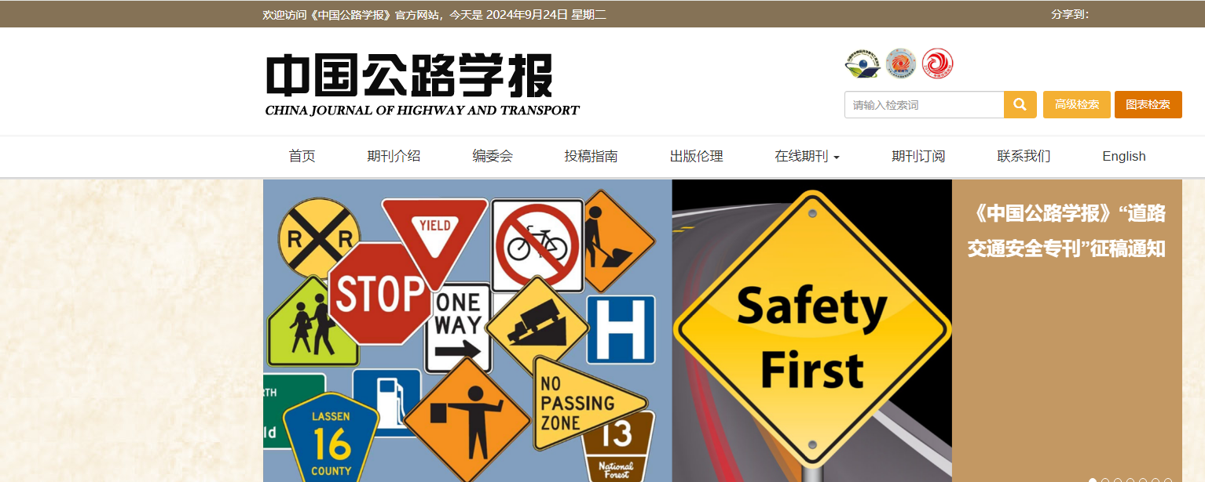

Click to view English translation

Click current issue

Click article title to capture meta data

Volume issue month date and year

Page range

Click to download PDF

DOI number

Article title