Source ID – 665547839

Source Title - Acta Agronomica Sinica (China)

Current Issue URL - <https://zwxb.chinacrops.org/EN/0496-3490/current.shtml>

Day

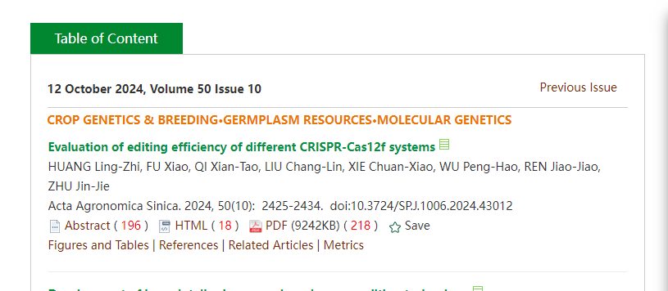

PDF

Month

Year

Volume

Issue

Pages

DOI

Article title