Source ID – 78473999

Source Title - Journal of Geomatics

URL - <http://chdlxx.whu.edu.cn/homeNav?lang=en>

**Both English and Chinese TOC should be added**

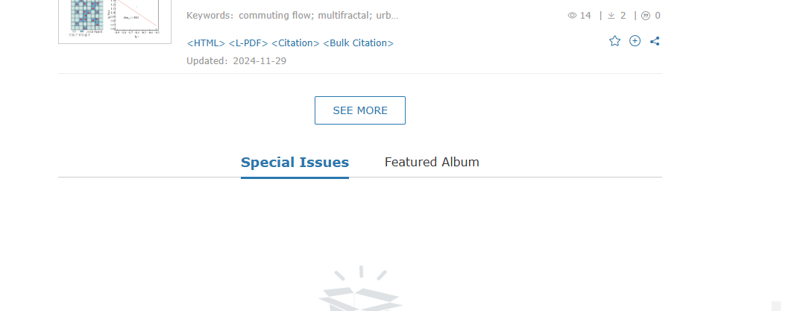

Scroll down and Select See more

Issue

Volume

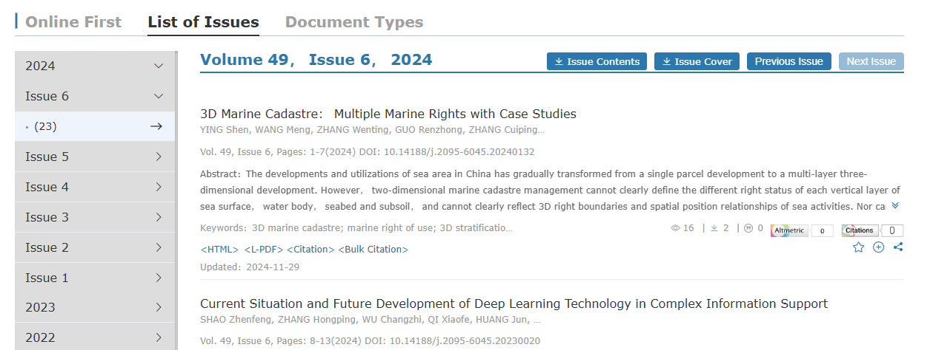

PDF

Page range

DOI

Article title

Year

Month is available in the PDF as shown below.

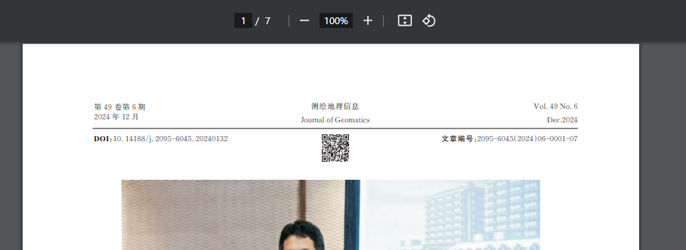

Month

Its available in short form as Dec should be captured as December.