Source ID – 78481299

Source Title - Chinese Journal of Evidence-Based Medicine

URL - https://english.cjebm.com/journal/zgxzyxzz/guokanliulan.html

**Both English and Chinese TOC should be added**

Page range

Article title

Latest Issue

Year

Click the article title.

DOI

PDF

Volume

Month is available in the PDF as shown below.

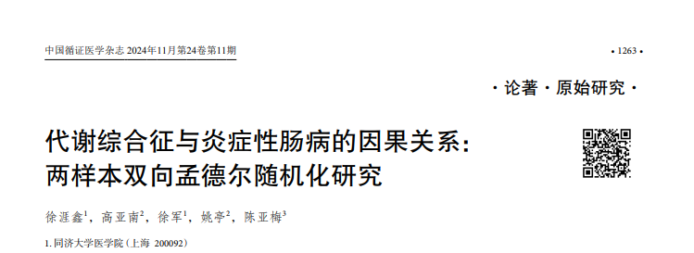

Month

Month is available in Chinese and should be captured in English.