Below source ids having same structure of websites

|  |  |
| --- | --- |
| Source id | BASED URL |
| 76648299 | https://www.jstage.jst.go.jp/browse/jsotp/-char/en |
| 76651299 | https://www.jstage.jst.go.jp/browse/jjes/29/3/_contents |
| 76657699 | http://www.jstage.jst.go.jp/browse/tonyobyo |
| 76678899 | https://www.jstage.jst.go.jp/browse/yakushi/list/-char/en |
| 76706799 | https://www.jstage.jst.go.jp/browse/jser/list/-char/en |
| 76837599 | https://www.jstage.jst.go.jp/browse/internalmedicine/list/-char/en |
| 76852799 | https://www.jstage.jst.go.jp/browse/bpb/list/-char/en |
| 76967299 | https://www.jstage.jst.go.jp/browse/jcbn/55/2/_contents/-char/en |
| 76971099 | https://www.jstage.jst.go.jp/browse/mycosci/56/2/_contents/-char/en |
| 76242799 | <https://www.jstage.jst.go.jp/browse/arerugi/list/-char/en> |
| 76317299 | https://www.jstage.jst.go.jp/browse/cpb/list/-char/en |
| 76327299 | https://www.jstage.jst.go.jp/browse/cytologia/84/3/_contents/-char/en |
| 76382899 | https://www.jstage.jst.go.jp/browse/haigan/list/-char/en |
| 76452499 | https://www.jstage.jst.go.jp/browse/orltokyo/list/-char/en |
| 76532599 | https://www.jstage.jst.go.jp/browse/jpnjurol1928/list/-char/en |
| 76536699 | https://www.jstage.jst.go.jp/browse/gee/list/-char/en |
| 76541699 | https://www.jstage.jst.go.jp/browse/ojjscn/50/1/_contents/-char/en |
| 76609599 | https://www.jstage.jst.go.jp/browse/clinicalneurol/list/-char/en |
| 76634899 | https://www.jstage.jst.go.jp/browse/shokueishi/list/-char/en |

**Go to the website using based url.Then landing page will appear like this**

* Select the CURRENT issue from the issue list.

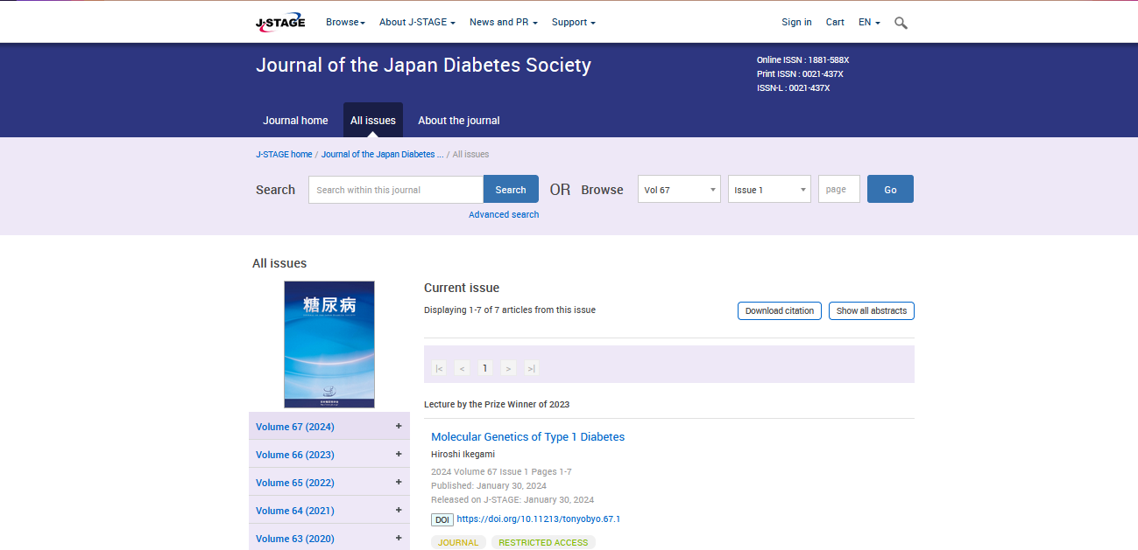

**Select the Current issue from here.**

* **All required articles will be listed here.**

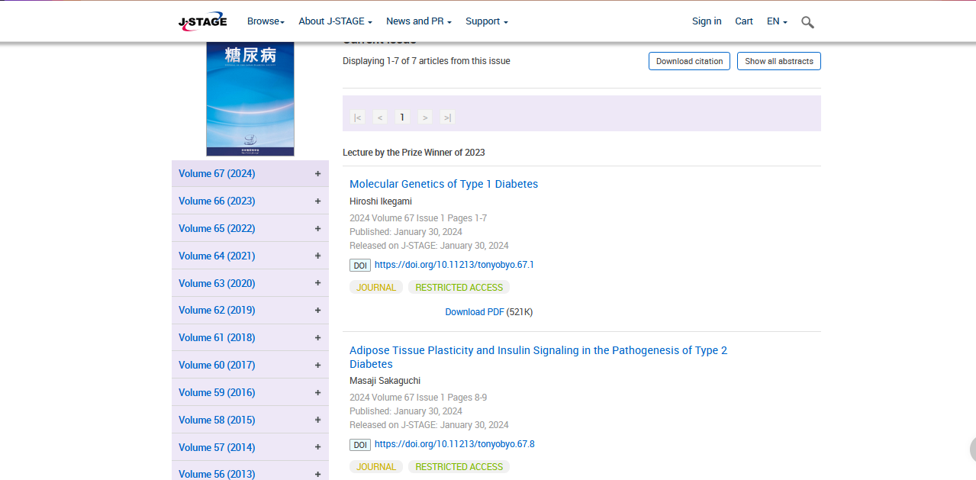

* **Meta data can be captured as below.**

**Volume, issue and Year, PAGE RANGE**

* **Click the article name to open the article information page to download the PDF.**

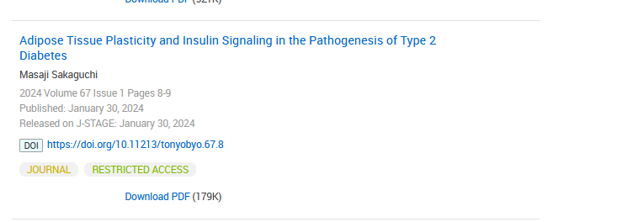

**Article name**

**DOI (start with 10)**

**Click the download link to download the PDF.**

**Page Range**