**Following source ids having same structure**

|  |  |
| --- | --- |
| Source | Based url |
| 76468999 | https://www.jstage.jst.go.jp/browse/jibiinkoka/list/-char/en |
| 77902399 | https://www.jstage.jst.go.jp/browse/ast/list/-char/en |
| 77939499 | https://www.jstage.jst.go.jp/browse/jorsj/list/-char/en |
| 78011999 | https://www.jstage.jst.go.jp/browse/circj/list/-char/en |
| 78077599 | https://www.jstage.jst.go.jp/browse/psysoc/list/-char/en |
| 78079099 | https://www.jstage.jst.go.jp/browse/serdj/list/-char/en |
| 78081699 | <https://www.jstage.jst.go.jp/browse/jsfp/list/-char/en> |
| 78081799 | https://www.jstage.jst.go.jp/browse/nskkk/list/-char/en |
| 78082299 | https://www.jstage.jst.go.jp/browse/ojjams/list/-char/en |
| 78108599 | https://www.jstage.jst.go.jp/browse/suisan/list/-char/en |
| 78136999 | https://www.jstage.jst.go.jp/browse/jibirin/list/-char/en |

Go to the based url so the landing page will be appear like below

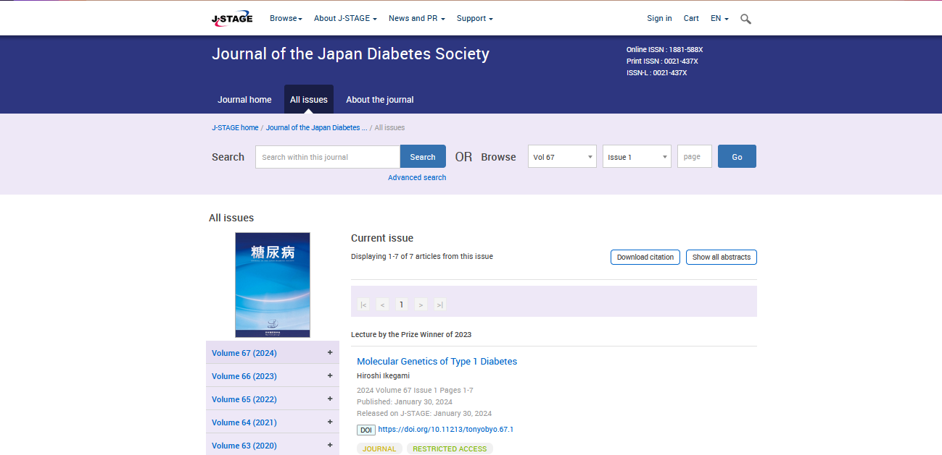

**Select the Current issue from here.**

* **All required articles will be listed here.**

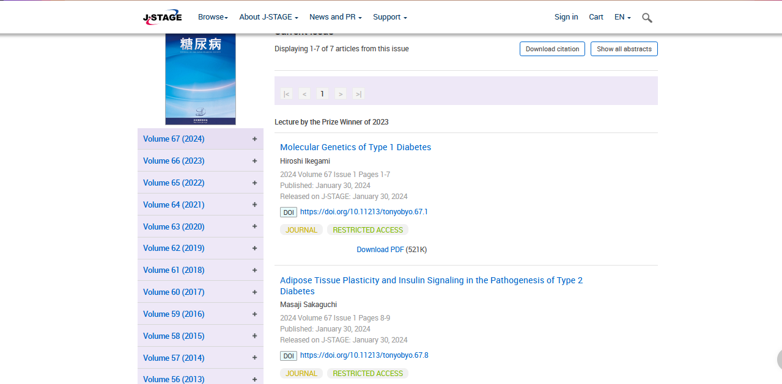

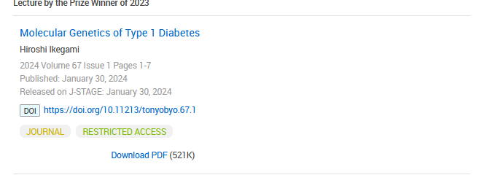**Meta data can be captured as below.**

**Volume, issue and Year, PAGE RANGE**

* **Click the article name to open the article information page to download the PDF.**

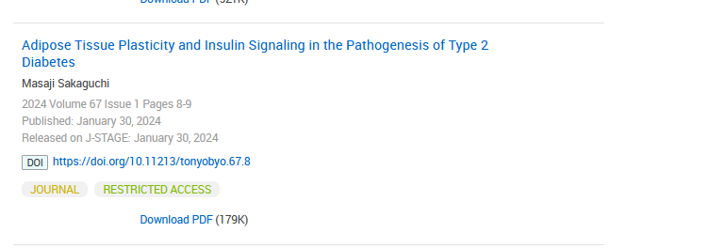

**Article name**

**DOI (start with 10)**

**Click the download link to download the PDF.**

**Page Range**