**835359963**

Base URL:

**agreement URL :** http://www.chebsbornik.ru

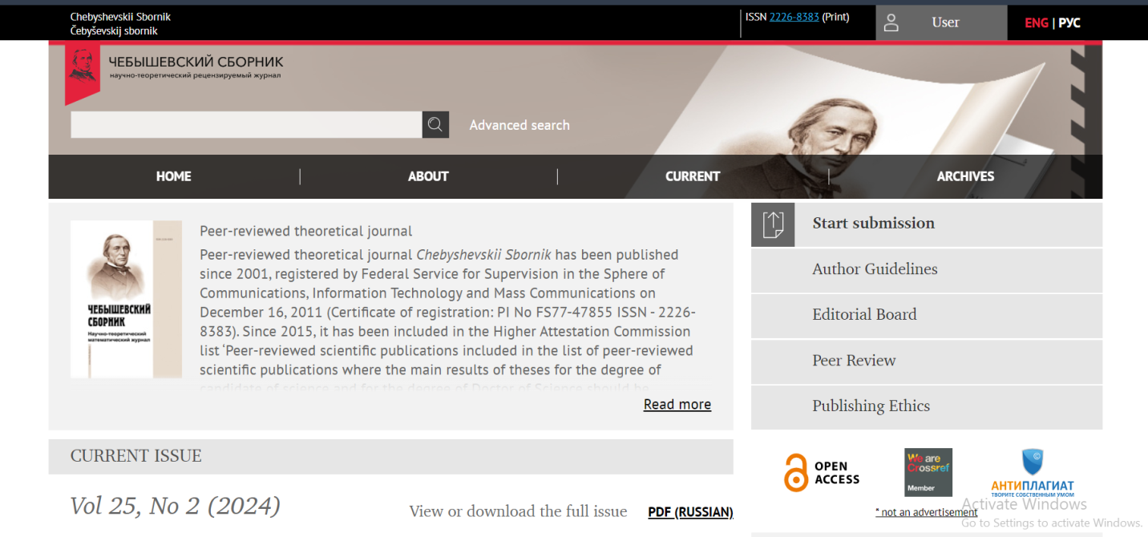Go to the website and change the language in to English from website language conversion.

**Select the current issue from here.**

* **All required articles will be listed here.**

**issue**

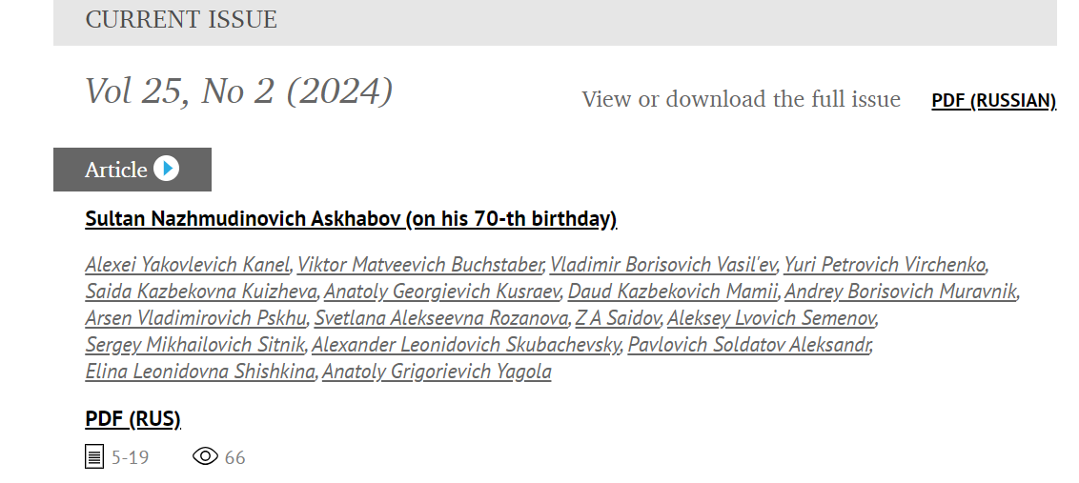

**Volume**

**Year**

**Capture and click article title**

**Page range**

You will get article page like below.

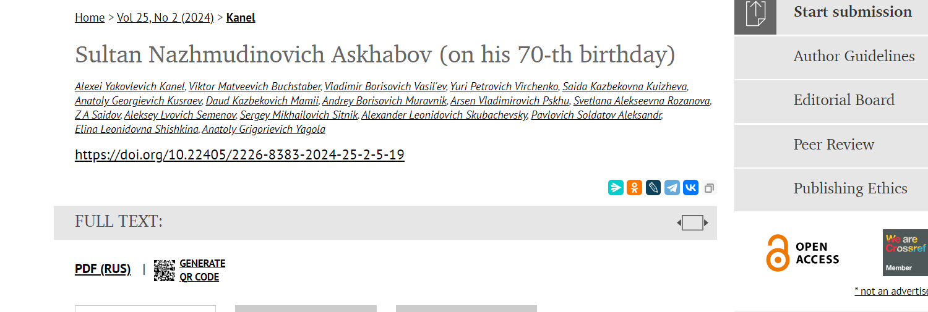



**doi**



Need both nonr oman and English tocs

**Then click here to download pdf**