**945574299**

Base URL:

**agreement URL :** https://tehnickiglasnik.unin.hr

**Use the source URL because its difficult find the correct journal with using the agreement URL**.

* Select the issue from the issue list.
* 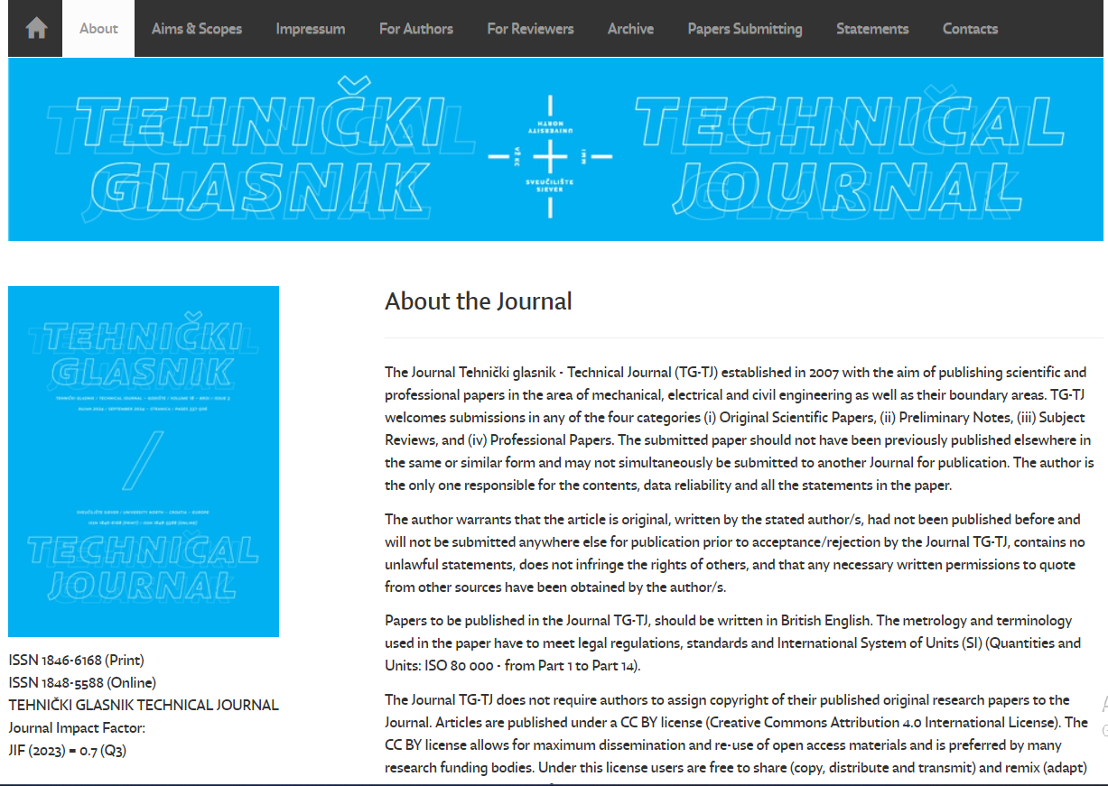

**Click here to get archive**

* **Archive will listed here.**

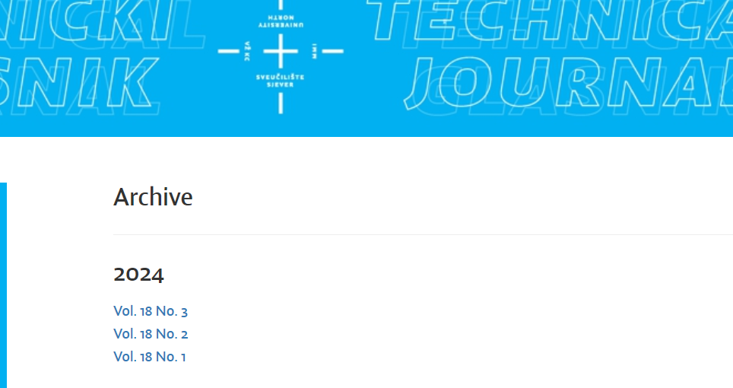

**Select the latest issue from here**

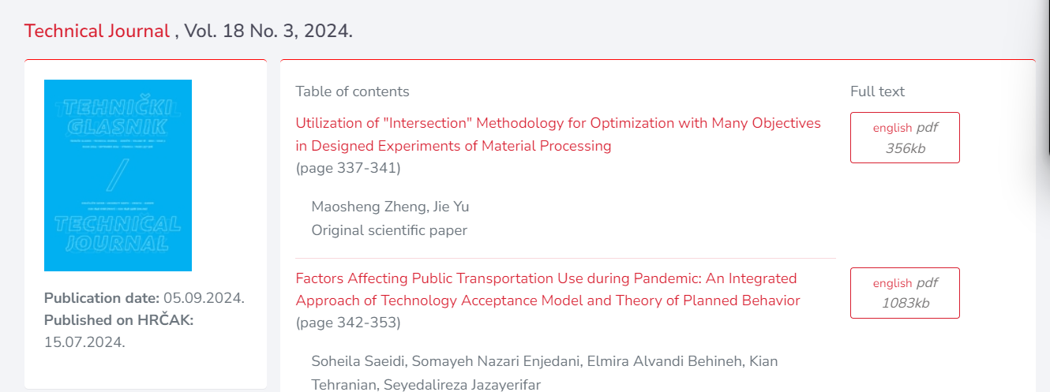

**Year**

**Volume**

**Issue**

**Capture and click article title**

* Meta data can be captured as below.

After clicking article title you will get article page like below.

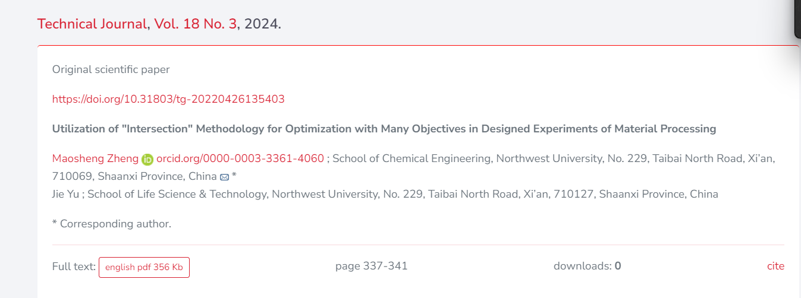



**doi**



**Page range**

* **Click the article name to open the article information page to download the PDF.**



**Then click here to download pdf**