|  |  |
| --- | --- |
| Source id | Base URL |
| 79029499 | https://revistas.unav.edu/index.php/estudios-sobre-educacion |
| 79461899 | https://revistas.unav.edu/index.php/anuario-filosofico |
| 79568599 | https://revistas.unav.edu/index.php/revista-de-arquitectura |
| 79790599 | https://revistas.unav.edu/index.php/rilce |
| 80002599 | https://revistas.unav.edu/index.php/anuario-de-historia-iglesia |
| 299311399 | https://revistas.unav.edu/index.php/scripta-theologica |
| 645485834 | https://revistas.unav.edu/index.php/studia-poliana |
| 645485866 | https://revistas.unav.edu/index.php/myc |
| 646879326 | https://revistas.unav.edu/index.php/ius-canonicum |
| 908994700 | https://revistas.unav.edu/index.php/la-perinola |
| **Above Source websites has same structure of websites** | |

**1)Select the Current issue from here.**

* **All required articles will be listed here.**

* **Meta data can be captured as below.**

**4)Capture Year**

**2)Capture Volume**

**3)Capture issue**

* Click the **pdf** link and it redirect to the download page and can download by this page.

**6)click article title**

**6)Page Range**

**5)Capture Title**

You will get article page

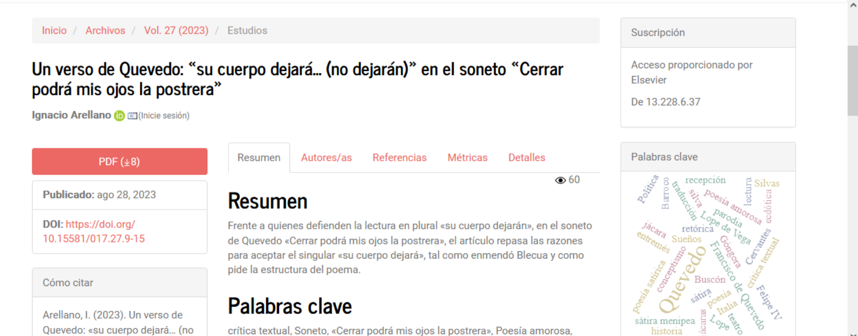

8)Click pdf button to download pdf

7) Capture Doi number