**78063699**

**Source URL:** http://epubs.icar.org.in/ejournal/index.php/IJAnS/issue/archive

* Use the source URL because it’s difficult find the correct journal with using the agreement URL.
* All the volumes are included in a single page

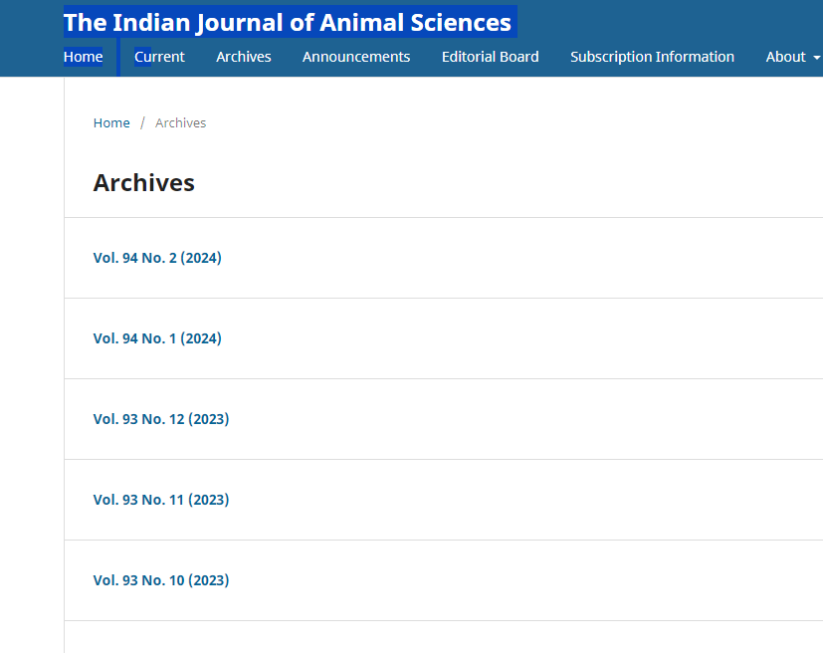

All the volumes and year

* If you want to get current volume and issue. Click here



Click here

* Select volume icon that highlighted in BLUE color to access all the articles.



Click here

## Meta data can be captured as below

## 

Volume , issue and year

Article title

DOI and URL

PDF to download