|  |  |
| --- | --- |
| 78170799 | http://rgjtxb.jtxb.cn/EN/1000-985X/current.shtml |

Need both Chinese and English toc.

Go to the website using the based url.

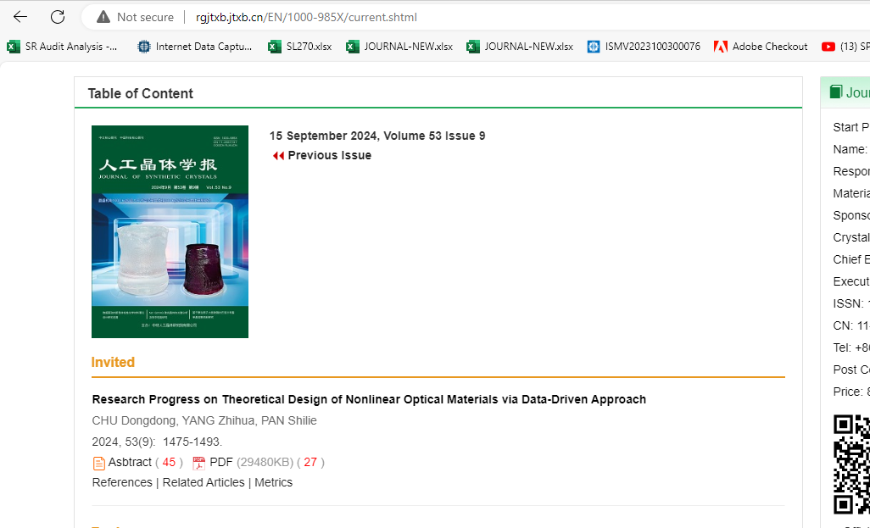

Download pdf

Date

Month

Year

Article title

Page range

Volume

Issue