**76601699**

Base URL:

<http://www.europeanreview.org/>

* Go to the website with base url
* Select the issue from the issue list.

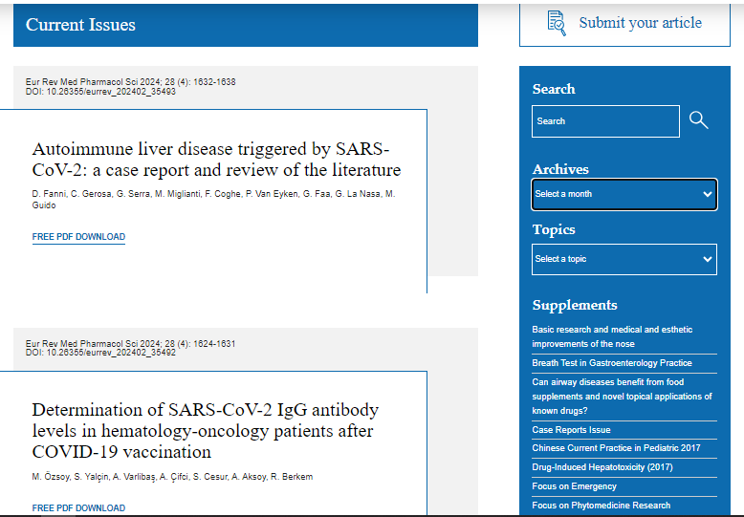

**Select the Current issue from here.**

* After selecting the issue content will appear here.



Page range

Title

* All required articles will be listed here



**Year **

**Volume, issue**

**DOI**

**Then click here to download the pdf**