Source ID - 77888299

Source Title - Xitong Gongcheng Lilun yu Shijian/System Engineering Theory and Practice

Agreement URL - http://www.sysengi.com

NOTE – English and Chinese TOC should be captured.

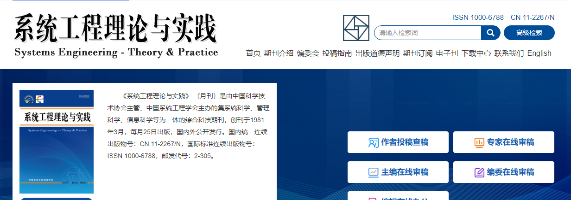

Click to view English translation

Click current issue

Click article title to capture meta data

Volume issue month date and year

Page range

Click to download PDF

DOI number

Article title