|  |  |
| --- | --- |
| 78085699 | https://journals.upress.ufl.edu/jpms |
| 930239700 | <https://journals.upress.ufl.edu/fa/index> |
| 930239702 | https://journals.upress.ufl.edu/bioarchaeology |

* Above source websites have same structure of website



**Select the Current issue from here.**

All required articles will be listed here.

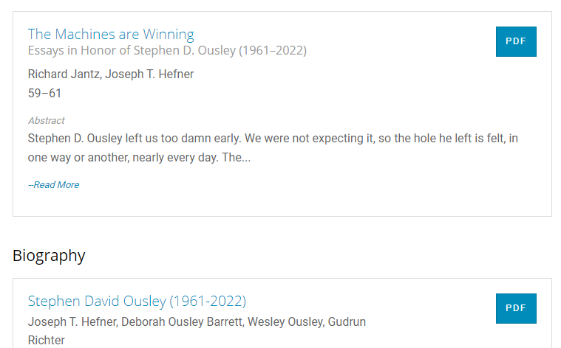

**Page Range**

Meta data can be captured as below.

**Volume, issue and Year**





**DOI**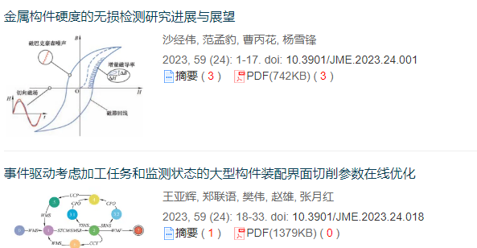

**Click here to download the pdf**

**Article Name**