Source ID: 78893799
Source Title: IEICE Electronics Express
Current Issue URL: https://www.ieice.org/publications/elex/index.html?current=1

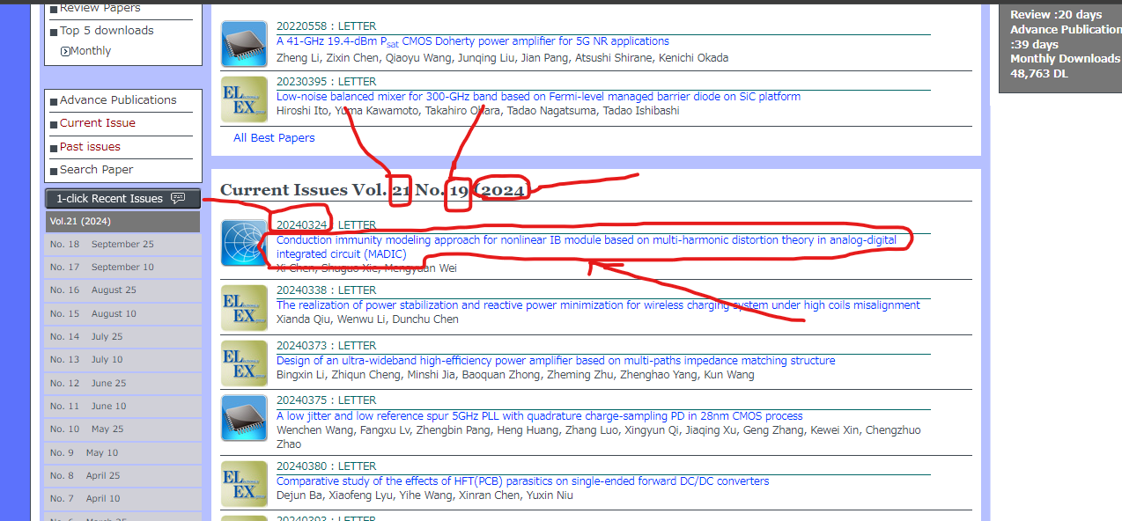
Click on Title
Article number
Volume
Issue
Year

DOI
Title
PDF
