76314899 | http://www.docdocpro.fr/revues/concours-medical
667440332 | http://www.docdocpro.fr/revues/egora-hebdo
667440333 | https://www.docdocpro.fr/revues/revue-francaise-dommage-corporel

- Use the source URL because it’s difficult find the correct journal with using the agreement URL.

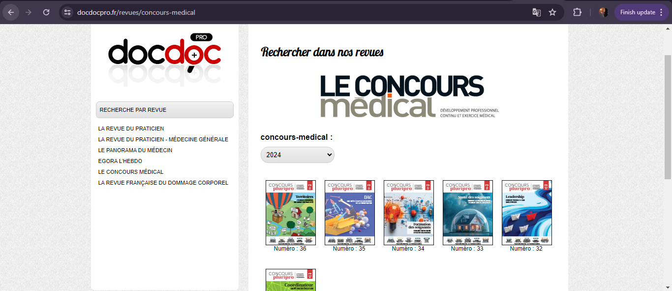

Year

Issue
Select the current issue from here.

Kindly note for source id 76314899 Volume number will be appear on article pdf only,operator should capture manually.
- All required articles will be listed here.
Article Title
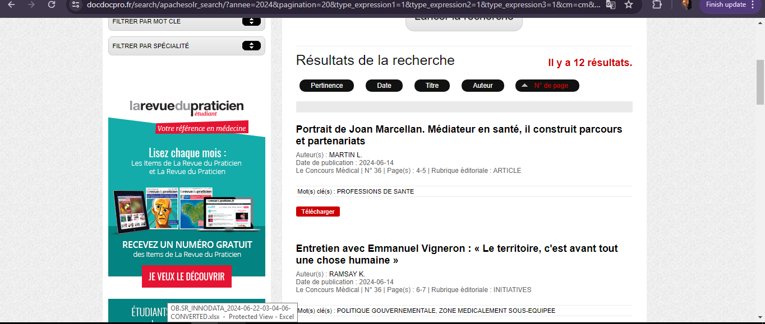
Meta data can be captured as below.
Page range

- Click the article name to open the article information page to download the PDF.
Then click here to download PDF

