76635899
Agreement url:
https://www.actaps.com.cn/archive_en.php

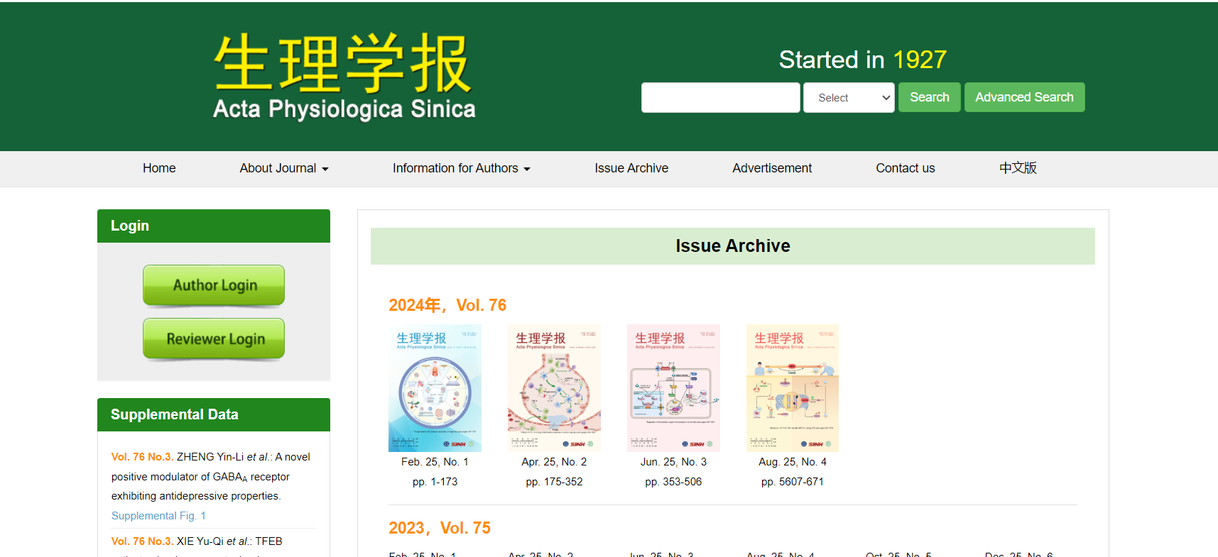
Publication year, Month, Date, volume, issue
Current issue
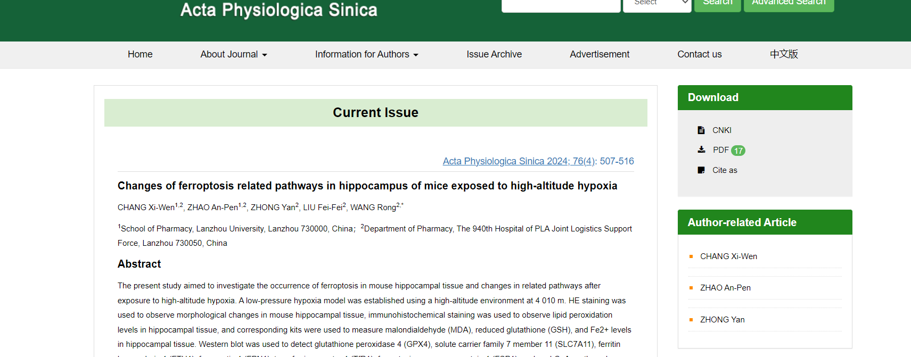
Page range
English title
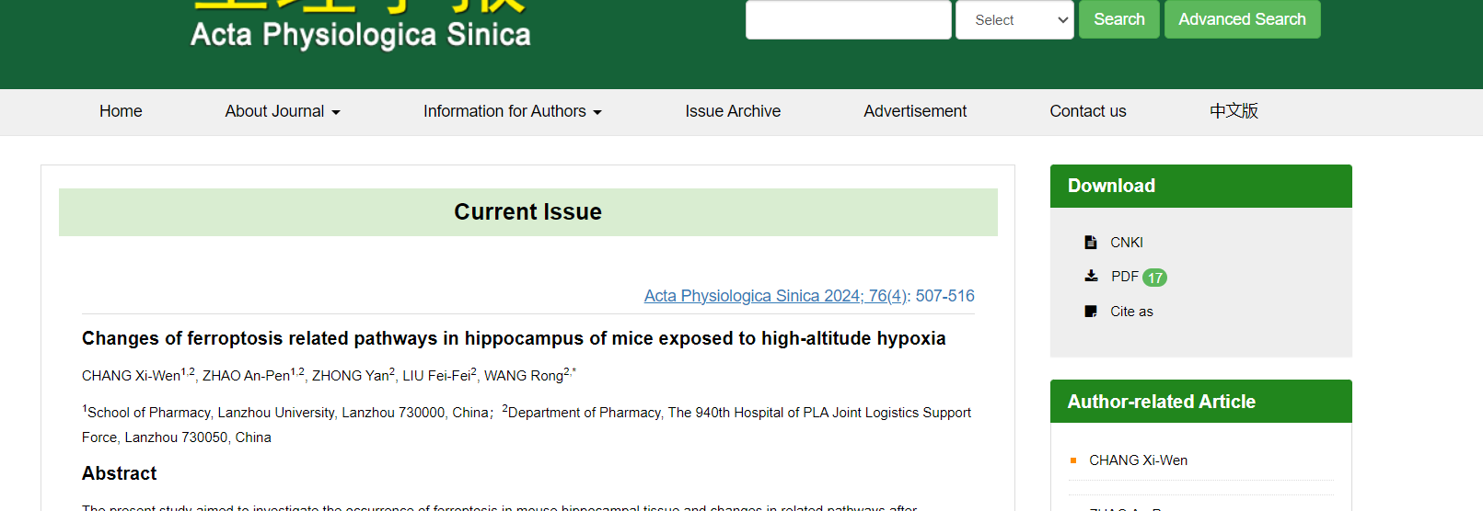
Click
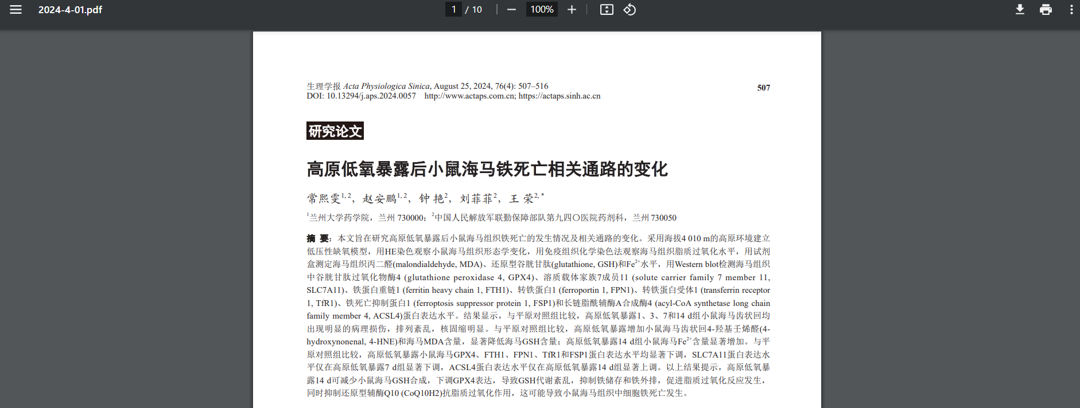
Download the pdf
DOI

- In here both English and Chinese toc needs to be captured so choose language option from website language conversion . then go to the Table of content page right click and save as pdf and merge in to one.

