Source ID - 78711099
Agreement URL - http://www.cjmit.com/cjmit/ch/index.aspx
- There is no English version of this website.
- The agreement URL directly takes to the Current issue of the Website.
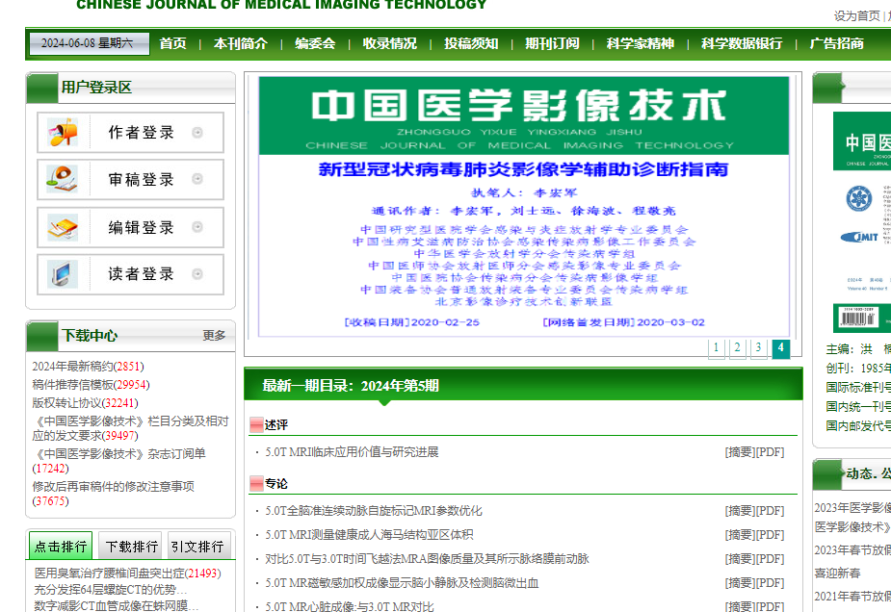
Click on the articles to capture data
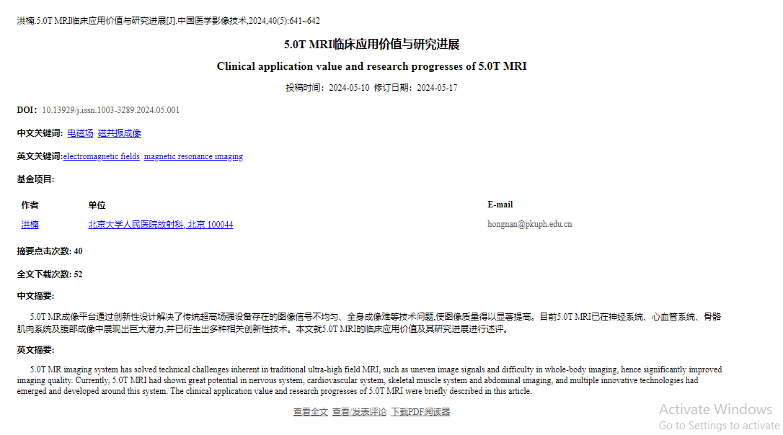
DOI
Click here to download PDF
Article title
Page range
Year, Volume and issue

