320888999 | http://zgspxb.cnjournals.org/zgspxben/home?id=20230331105127001&name=English

Go to the website using the based url.You will get web page like below

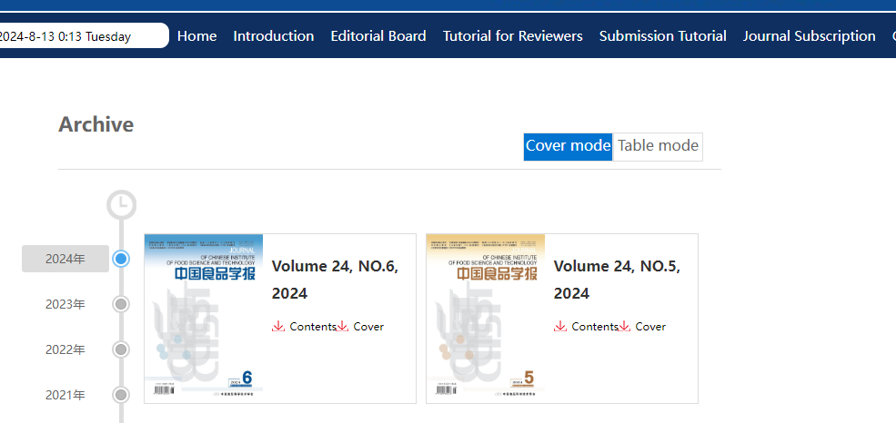
Select the latest issue from here

You will get current issue page like below.

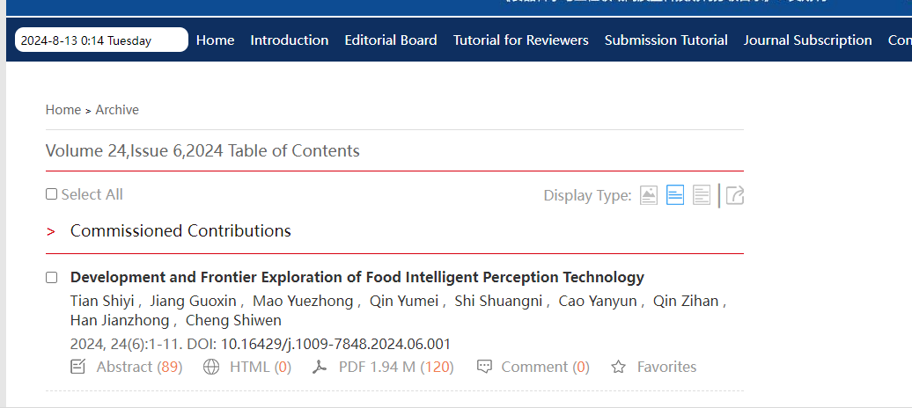
doi
Article Title
Click here to download
Page range
Issue
Year
Volume

Need both non roman and English tocs.

