295935599 | https://revista.spemd.pt/issues

Go to the website using the based URL,you will get latest issue page like below
Capture Volume
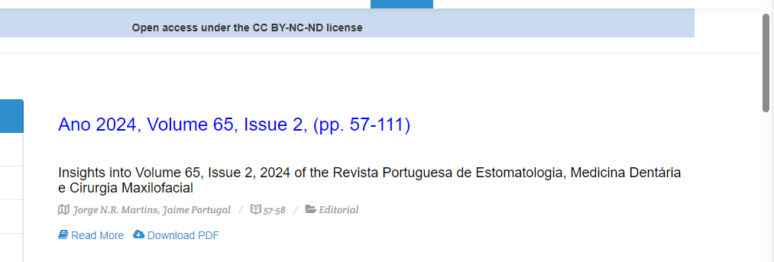
Capture and click article title
Capture issue
Capture Year

After clicking article title you will get article page like below
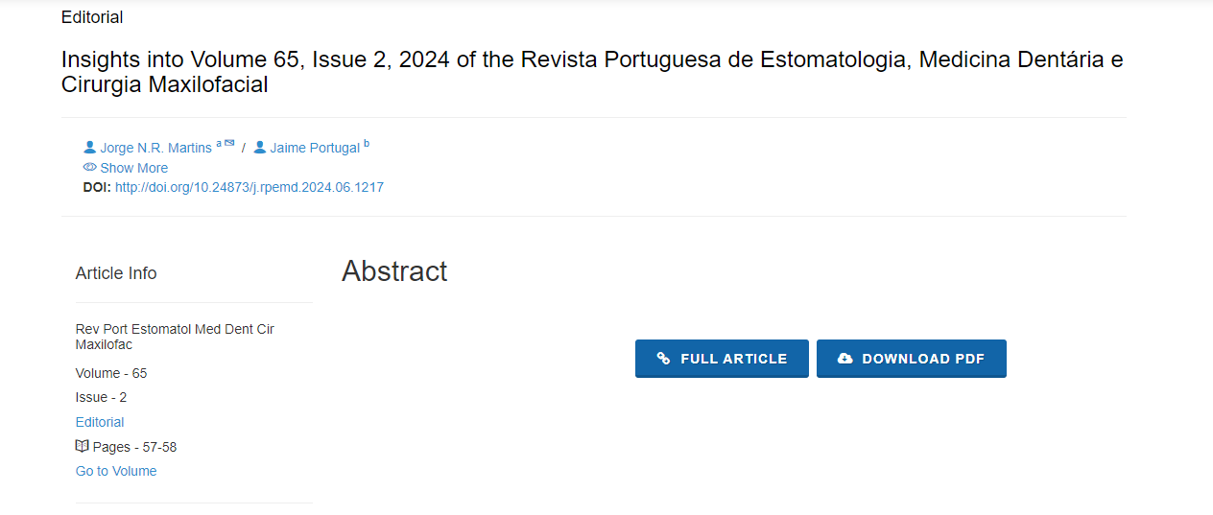
Click here to download pdf
Page range
DOI

