Source ID - 79791299
Source Title - Indian Journal of Animal Research
Agreement URL - https://arccjournals.com/journal/indian-journal-of-animal-research

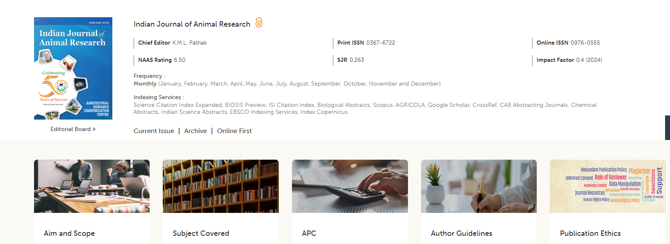
Click current issue to browse current issue

Issue
Article title
Page range
Volume

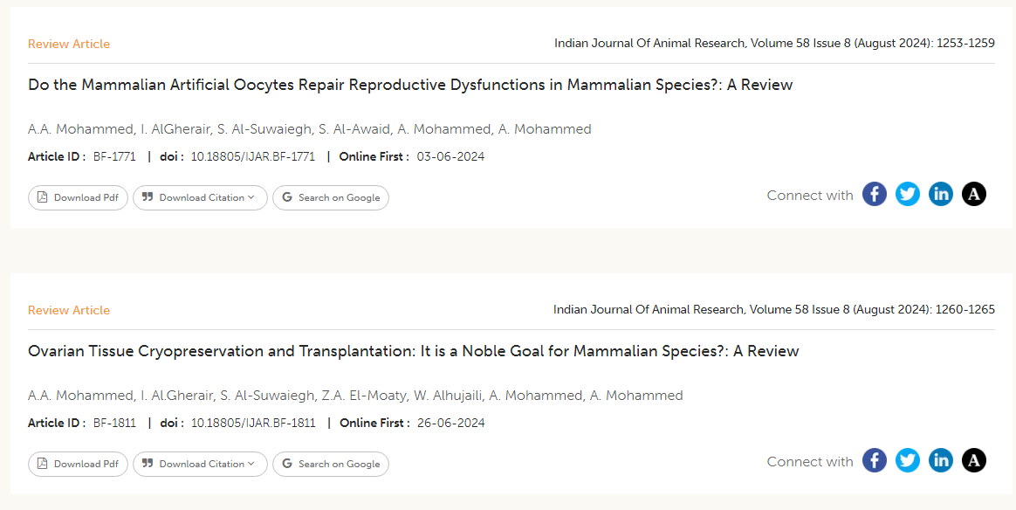
Click here to download pdf
Month
Year
Identifier
Doi

