Source ID - 76416399
Source Title - Investigative Ophthalmology and Visual Science
Agreement URL - https://iovs.arvojournals.org/issues.aspx
Click here to download pdf

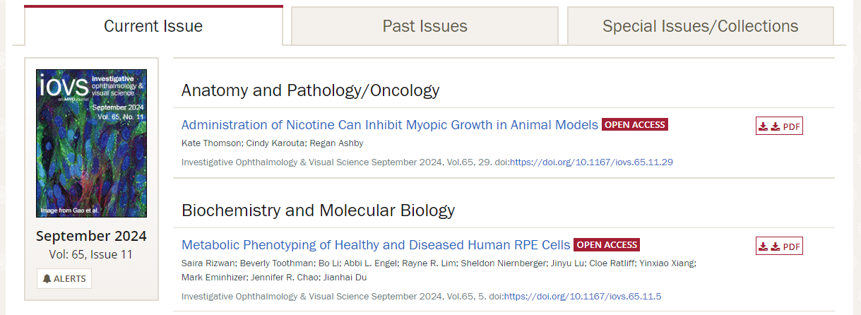
Identifier
Article title
DOI number
Month
Volume
Issue
year

