942065018

Base URL:

Agreement URL : https://www.afjbs.com/archive

- Select the current issue from the issue list.

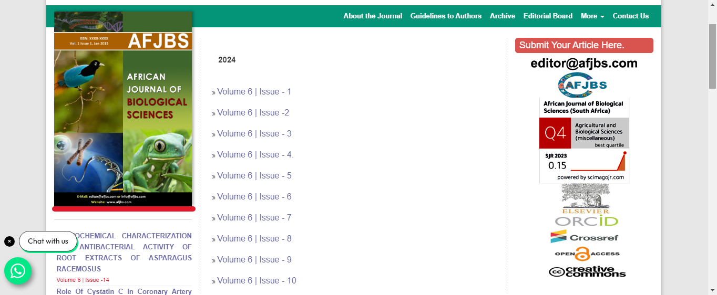
Capture volume issues and click

- After selecting the issue content will appear here.

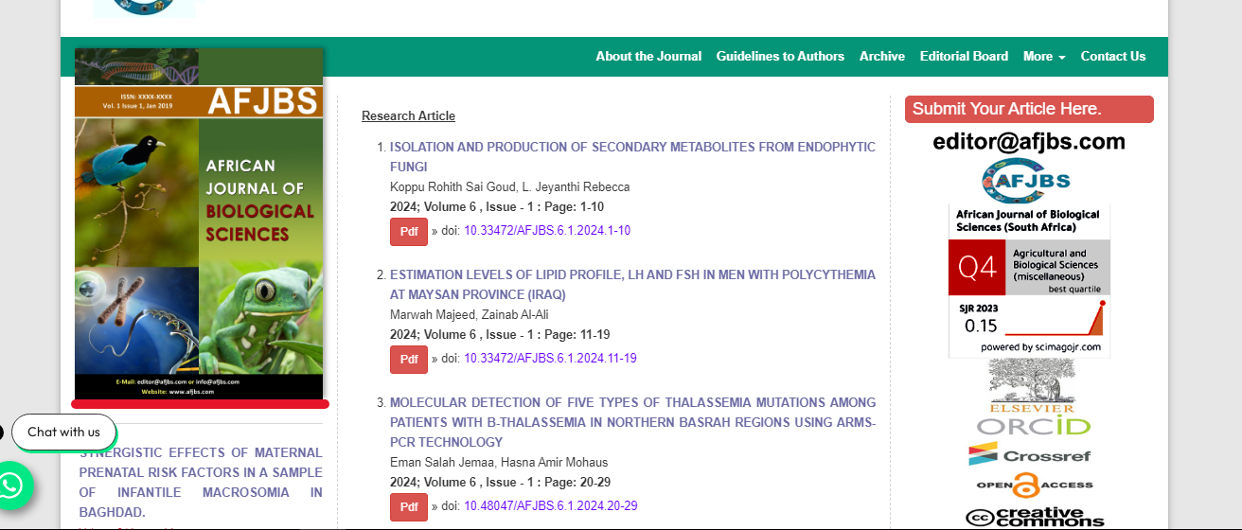
title

- Click the selected title.


year
Page range
Doi
Then click here to download the pdf

- Then pdf will appear.
- Click the download for download the pdf

