939594941 | https://manu60.magtech.com.cn/biotech/EN/1671-8135/home.shtml
Go to the website using the based url.

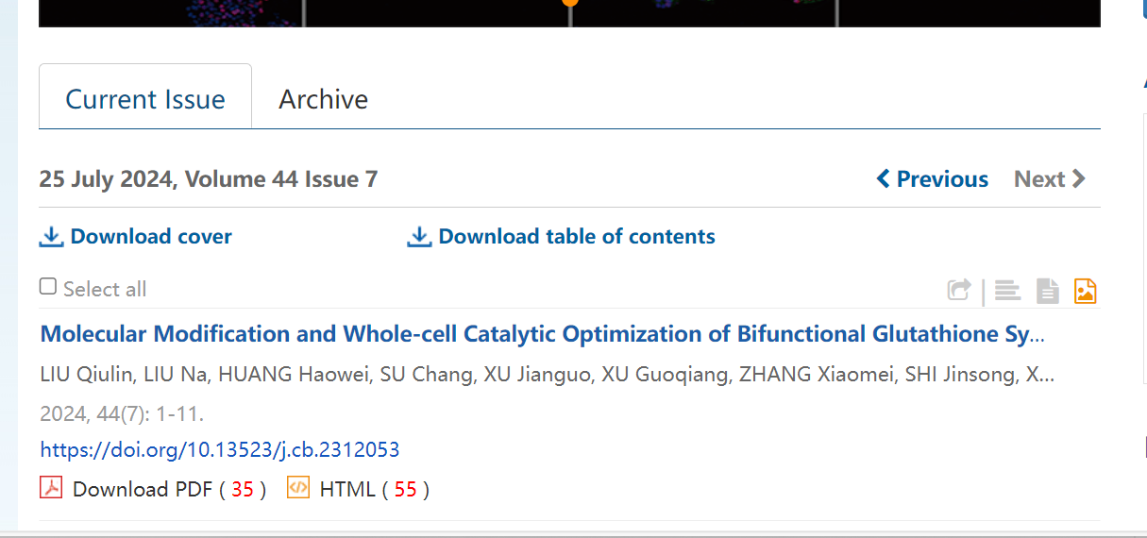
Download pdf
Page range
Volume
Issue
Year
Month
Date
DOI
Article title

Need both non roman and English tocs.

