Source ID - 76893999
Source Title - Journal of the College of Physicians and Surgeons Pakistan
Agreement URL - https://www.jcpsp.pk/
Year
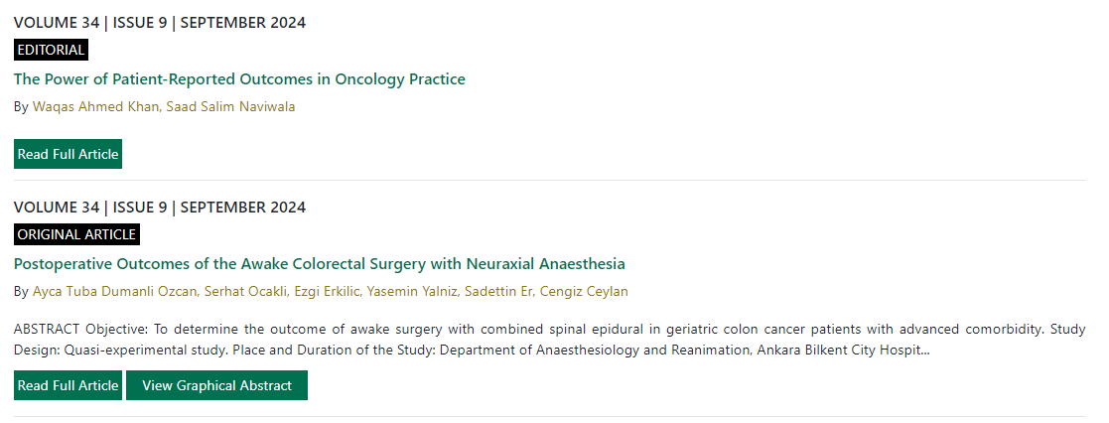
Volume
Issue
Month
Click read full article to capture meta data

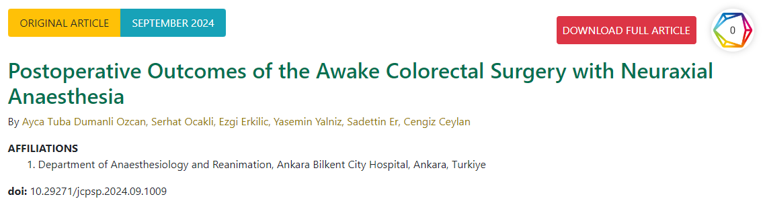
DOI number
Article title
Click to download PDF

