939594944- http://fcst.ceaj.org/EN/1673-9418/current.shtml
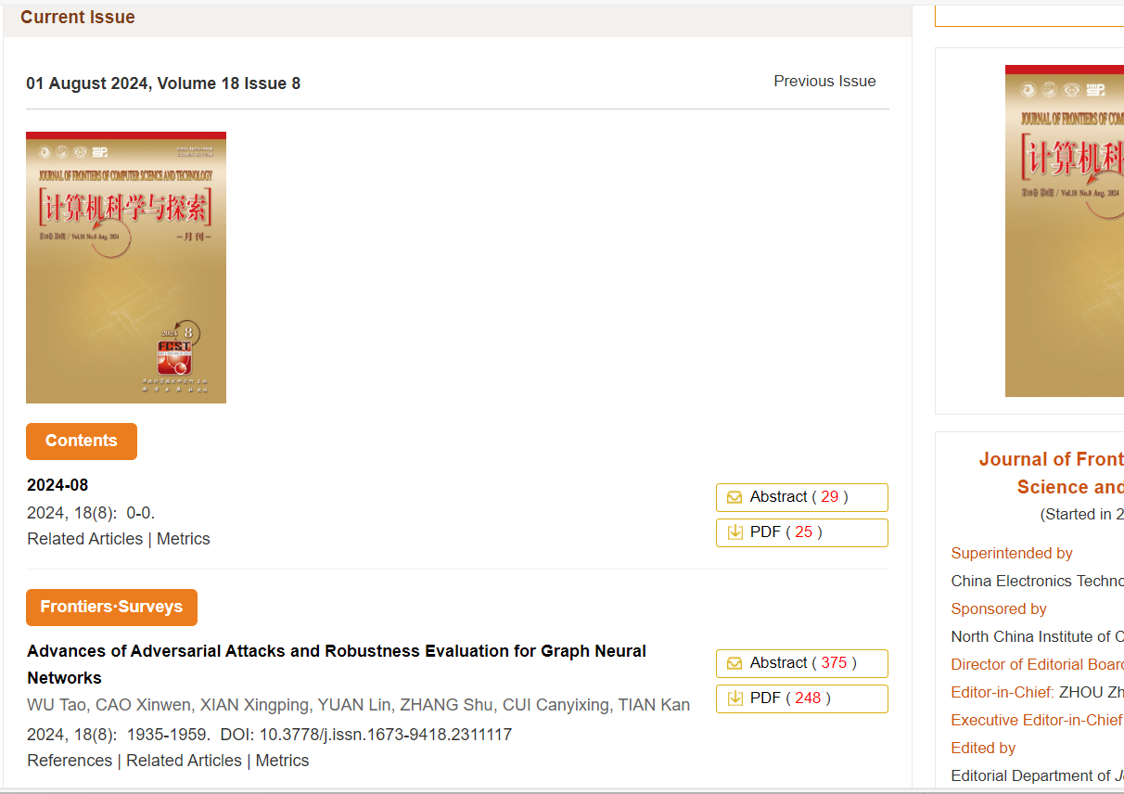
Download pdf
DOI
Page range
Article title
Month
Year
Volume
Issue
Date

Need nonroman and English tocs.

